|  |
| --- |
| Smart Select Glasses |

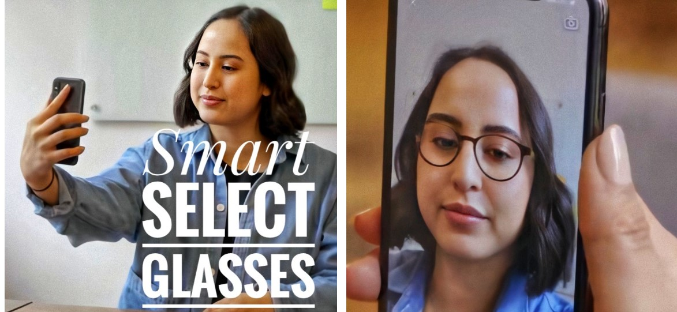

**Name:** Mohamed Magdy Mohamed Tawfik Diab

**Tile of the project:** Smart Select Glasses (SSG)

**Supervisor:** DR. Sara Nabil

**Type:** Report

* **Declaration:**
* **Declaration of No Plagiarism by Student:**

**I hereby declare that this submitted report work is a result of my efforts and I have not plagiarized any other person's work. I have provided all references for the information that I have used and quoted in my report work.**

* **Name of Student: Mohamed Magdy Mohamed Tawfik Diab**
* **Abstract:**

**Eyeglass buying is difficult. The glasses you picked ought to comply with your appearance, individual taste, face shape, and shading. Some types of lenses don't go along with certain frames. for instance, progressive lenses usually don't match smaller, stylish frames. Buying eyeglasses online has both advantages and disadvantages. Therefore, my program provides an appropriate environment for purchasing elegant glasses that suit your face, The system will Increase demand for purchasing glasses and good coding system characteristics (usability, flexible, reliable, and usable).**

* **Aim:**
* **Design and implement an integrated system that allows the user to purchase the appropriate glasses.**
* **increase the sales of glasses.**
* **capture and analyze a face with AI to select 100% accuracy.**
* **saves customers time and money.**

* **Acknowledgments:**

**I would like to thank Allah for facilitating writers this report despite the lack of time.**

**I thank all Arab Open University members, inside and outside the Arab countries, because they give me the chance to improve my education skills and they paved the way for entering the ICT world, which is the most important knowledge should everyone learn in our days.**

**I thank all Arab Open University individuals, inside and outside the Arab nations, since they allow me to improve my training aptitudes and they made ready for entering the ICT world, which is the most significant information should everybody learn in our days.**

**Special thanks to Dr. Sarah Nabil for the help in the project, thank you for being my teacher and guiding me on the right path to life. I am grateful to my teachers. Thank you for this wonderful year.**

**Special thanks also to Dr. Eid for helping me so much in artificial intelligence, as well as special thanks to Dr. Hala for guiding me on my academic career. I am very grateful to you. Thank you for this wonderful year.**

**Finally, Thank you for always believing in me, even when I didn't believe in myself. You made me what I am today. Thank you for everything, Dad and mom.**

|  |
| --- |
| Table of Contents  **Declaration 2**  **Abstract 3**  **Acknowledgments 4**  **Contents 5**  **Chapter 1: Introduction 6**  **1.1 Problem 6**  **1.2 Solution 7**  **1.3** **Aims and objectives of the project 7**  **1.4 Project scope 8**  **1.5 Target customer 8**  **1.6** **Planning the project 9**  **1.7 Report structure 11**  **Chapter 2: Literature Review of (SSG) …..12**  **2.1 OverView……………………………………………………………………………………………………………………………………………………….…………………………12**  **2.2 Similar systems…………………………………………………………………………………………………………………………….…………………………………………..12**  **2.2.1 A hybrid approach to building face shape classifier for hairstyle recommender system…………………………………………………..……12**  **2.2.2 Facial Recognition, Expression Recognition, and Gender Identification ………………………………………………………………………………..14**  **2.2.3 Automatic face identification system using flexible appearance models.………………………………………………………………….…………..15**  **Chapter 3: Requirements and analysis ……...16**  **3.1 Functional Requirement ……………………………………………………………………………………………………………………………………………………… 16**   * 1. **Non-Functional Requirements….. 17**   **3.2. 1 Usability .. 17**  **3.2.2Security………………………………………………………………………………………………………………………………………………………………………..…..…….17**   * + 1. **Performance…………………………………………………………………………………………………………..………………………………………………….....17**   **3.2 Software requirements………………………………………………………………………………………………………………………………………….………….….….17**  **3.4 Conceptual Modeling………………………………………………………………………………………………………………………………………..………………….....19**  **3.4.1 Use Case Diagram…………………………………………………………………………………………………………………………………………………………………19**  **3.4.2Flowchart diagram…………………………………………………………………………………………………………………………………………….………………….20**  **3.5 Activity Diagram……………………………………………………………………………………………………………………………………………………………………...21**  **3.5.4 Sequence diagram………………………………………………………………………………………………………………………………………………………………..24**  **Chapter 4: Implementation…………………………………………………………………………………………………………………………………………………………………………………...26**  **4.1 OverView…………………………………………………………………………………………………………………………………………………………….……………………...26**  **4.2 User interface………………………………………………………………………………………………………………………………………………………….…………………..26**  **4.3 APPLICATION SOURCE CODE……………………………………………………………………………………………………………………………….……………….……….62**  **Chapter 5…………………………………………………………………………………………………………………………………………………………………….……………………..62**  **5.1 HOW DOES APPLICATION WORK……………………………………………………………………………………………………………………………….………………….62**  **Chapter 6…………………………………………………………………………………………………………………………………………………………………………………………...63**  **Conclusion………………………………………………………………………………………………………………………………………………..…….63**  **References………………………………………………………………………………………………………………………………………………………64** |

* **Contents:**
* Chapter 1:
* **Introduction:**

**Eyeglass buying is difficult. The glasses you picked ought to comply with your appearance, individual taste, face shape, and shading. Some sorts of lenses don't company with certain frames. as an example, progressive lenses usually don't match smaller, stylish frames. Buying eyeglasses online has both advantages and disadvantages. Therefore, my program provides an acceptable environment for purchasing elegant glasses that fit your face, the system will Increase demand for purchasing glasses and good software characteristics (usability, flexible, reliable, and usable).**

**Sunglasses afford better vision in bright daylight and can protect one's eyes against damage from excessive levels of nonparticulate radiation. Typical sunglasses lenses are tinted for cover against bright light or polarized to induce eliminate glare; Photochromatic glasses are clear in dark or indoor conditions, but transform sunglasses when in they're available attached nonparticulate radiation. Most over the sunglasses haven't got remedial force inside the focal points, in any case, there is unique solution Particular glasses could even be utilized to review explicit visual information, for example, 3D glasses for 3D films (stereoscopy). Glasses are typically used for vision correction, also like reading glasses and glasses used for nearsightedness.**

* 1. **Problem:**

**Many people don't have time to go to the glasses store; to buy glasses that fit their face, so some go to buy glasses from many sites such as Amazon or Souq and when the customer receives the order, they find that the glasses don't match the customer's face at all. The customer must recover the product and this costs the customer time and money as well as the service provider, so you decided to create a program to resolve this issue.**

* 1. **Solution:**

**I will create an application linked to a database that the service provider will display the merchandises thereon and also information about the merchandise and also the place of the sale so customer creates an account on the App and complete some information like gender: male or female so AI creates 3 frame choices per person, supported the customer’s face shape, gender, age, and also the foremost well-liked frames purchased by similar customers within the previous month.**

**The accuracy of the AI will increase over time because the customer’s previous frame choices on their customer record inform the frame choices.**

**Frame Styler identifies styles and hues range that suit the customer’s face best, allowing them to be confident in their choices, The technology shows each frame from various edges and empowers clients to for all intents and purposes take a stab at various styles in 3D, contrasting how they appear and one fast swipe.**

**Permitting. customers to work out first-hand how different glasses change their appearance from all angles. In trials, it's proved particularly popular short-sighted customers who don't wear contact lenses as they're visiting place their glasses back on after their scan and see clearly while they ‘try on’ new frames.**

**and after you press “accept”, the appliance displays all the knowledge available for the glasses, like their price and places available Product and also the likelihood to request online.**

* 1. **Aims and objectives of the project:**
* **Increase sales of glasses.**
* **Helping the customer in choosing the best product for his face.**
* **Save money and time for the customer and service provider.**
* **Helping myopia clients who do not wear contact lenses can put their glasses back on after scanning and see clearly as they "try out" new frames.**
  1. **Project scope:**

**The proposed system will deal with the people involved. It is particularly introduced as an integrated platform for To buy and sell glasses.**

**The system interface will deal with the following:**

**1.** **Administrators: adding, updating information.**

**2.** **service provider: It displays its products and adds information about the product and the place of sale.**

**3.** **customer: Log in to the app to purchase the right and product and order online.**

* 1. **Target customers:**
* **The main stakeholders are:**
* **Administrators**
* **service provider**
* **customer**
  1. **Planning the project:**

|  |  |  |  |
| --- | --- | --- | --- |
| Task Name | Duration | Start | Finish |
| Planning stage | **22 days** | **11/2/2020** | **2/4/2020** |
| Thinking about an existing problem and solution | **4 days** | **11/2/2020** | **15/2/2020** |
| Getting out with a project idea | **2 days** | **16/2/2020** | **17/2/2020** |
| Refining the idea information | **7 days** | **17/2/2020** | **24/2/2020** |
| Initial work I the domain model | **6 days** | **24/2/2020** | **30/3/2020** |
| Deployment of the proposal | **3 days** | **31/2/2020** | **2/4/2020** |
| Requirement and analysis stage | 28 days | **3/4/2020** | **4/5/2020** |
| Working the requirement activities(elicitation, analysis, validating) | **5 days** | **3/4/2020** | **8/4/2020** |
| Refining functional and nonfunctional requirements | **3 days** | **9/4/2020** | **12/4/2020** |
| Building basic UML diagrams(use case, activity, and class diagram) | **8 days** | **13/4/2020** | **21/4/2020** |
| Submitting TMA 1 | **12 days** | **22/4/2020** | **4/5/2020** |
| Design stage | 47 days | 6/5/2020 | 28/6/2020 |
| Submitting report 1 | **7 days** | **6/5/2020** | **13/5/2020** |
| Building basic interaction diagrams | **6 days** | **14/5/2020** | **20/5/2020** |
| Start designing the user interface | **11 days** | **21/5/2020** | **1/6/2020** |
| Prepare and perform presentation 1 | **6 days** | **2/6/2020** | **8/6/2020** |
| Examination rest | **7 days** | **9/6/2020** | **16/6/2020** |
| Resume designing the user interfaces | **3 days** | **17/6/2020** | **20/6/2020** |
| Designing the database | **7 days** | **21/6/2020** | **28/6/2020** |
| Implementing stage | **84 days** | **29/6/2020** | **26/8/2020** |
| Exploration | **7 days** | **29/6/2020** | **5/7/2020** |
| Installation | **3 days** | **6/7/2020** | **9/7/2020** |
| Initial implementation | **17 days** | **10/7/2020** | **27/7/2020** |
| Full implementation | **50 days** | **28/7/2020** | **18/8/2020** |
| Submitting TMA 2 | **7 days** | **19/8/2020** | **26/8/2020** |
| Testing stage | 9 days | 27/8/2020 | 7/9/2020 |
| The testing unit, integration, and acceptance of the system | **2 days** | **27/8/2020** | **29/8/2020** |
| Fixing errors | **7 days** | **30/8/2020** | **7/9/2020** |
| Deployment stage | 19 days | 7/9/2020 | 27/9/2020 |
| Submitting report 2 | **8 days** | **7/9/2020** | **15/9/2020** |
| Prepare and perform the final presentation | **11 days** | **16/9/2020** | **27/9/2020** |

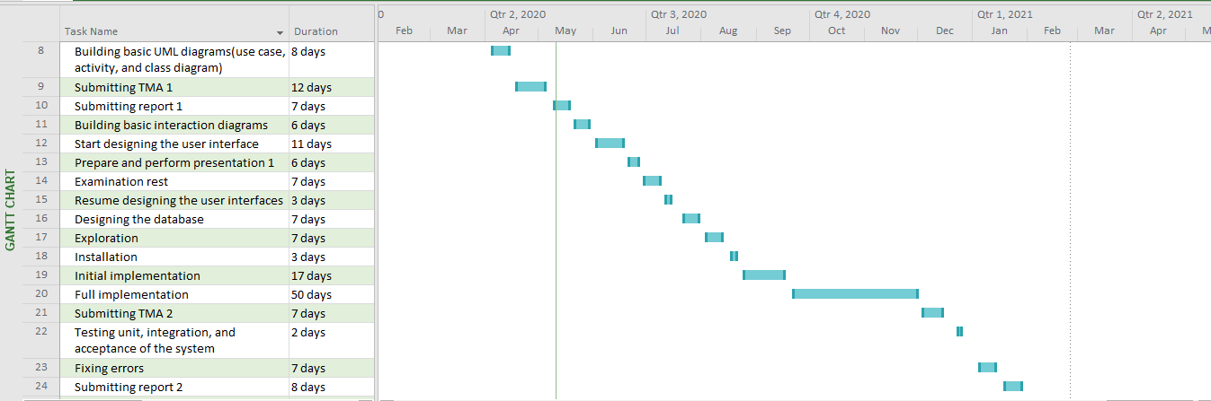

**1.7Report structure:**

* **This report is partitioned into the following parts:**
* **Chapter 1: is an Introduction that gives a little relevant background information about the project.**
* **Chapter 2: is a Literature Review includes an overview of similar systems.**
* **Chapter 3: is about analyzing the system requirements.**
* **Chapter 4: includes system design and implementation.**
* **Chapter 5: includes results and discussions about the system outcome.**
* **Chapter 6: contain the final comment on the system outcome.**
* **Chapter 2: literature view:**

**2.1 Overview:**

**Through this chapter, I will focus on getting an idea of the use of artificial intelligence in choosing glasses.** **It is considered as a review of relevant work done by other developers and the relationship between them and mine.** **This part will be useful to gain rich ideas to apply to my system. I spent a long time searching for a software that has exact similar tasks of mine, but I didn’t find, so I will list below some systems that have a subset of common tasks with mine.**

2.2 Similar systems:

2.2.1 A hybrid approach to building face shape classifier for hairstyle recommender system:

**Recognizing human face shape is the first and the most imperative procedure before picking the correct hairdo to wear on as per rules from haircut specialists, particularly for ladies. This work presents a novel structure for a hairdo recommender framework that depends on the face shape classifier. This structure empowers a programmed haircut proposal with a solitary face picture. This directly affects the excellence of industry specialist organizations. It can mimic how the client appears as though when she is wearing the picked haircut suggested by the master framework.**

* **Advantages:**
* **Using the (VGG – Face) descriptor for face acknowledgment task broadly utilized pre-prepared models by the university of oxford 2015.**
* **Using (AAM) is one of the most famous models-based methodologies that have been widely used to remove includes by exceptionally exact demonstrating of human faces under different physical and ecological conditions.**
* **Disadvantage:**
* **The application is used for women only.**
* **The samples are few.**

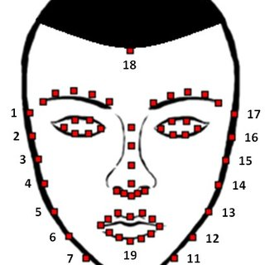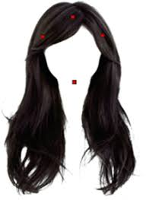

**2.2.2 Facial Recognition, Expression Recognition, and Gender Identification:**

**Face recognition has many important applications in areas like public surveillance and security, biometric authentication within the digital world, and modeling techniques in multimedia data management. countenance recognition is additionally significant for focused showcasing, clinical investigation, and human-robot cooperation.**

* **Advantage:**
* **The system automatically recognizes the face, whether in pictures or videos.**
* **The system recognizes all facial expressions.**
* **Through the image, the system can determine the gender and age.**
* **Disadvantage:**
* **The age limit is limited to 30 to 70 only.**
* **When analyzing an image of poor quality, the accuracy of the program decreases to 69.3%.**
* **The system does not operate very efficiently.**

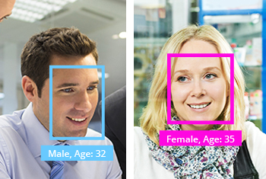

**2.2.3 Automatic face identification system using flexible appearance models:**

**We portray the utilization of adaptable models for speaking to the shape and dim level appearance of human countenances. These models are constrained by few parameters which can be utilized to code the general appearance of a face for picture pressure and characterization purposes.**

* **Advantages:**
* **using Model (PDM)2 in the system and is a factual parametric model item, which is a basic piece of many deformable models.**
* **the classification of faces based on shape.**
* **This model is utilized related to at least one adaptable dark level model so each face can be described by a set of the shape model.**
* **Disadvantage:**
* **errors may be caused by a failure in locating landmarks accurately.**
* **errors may be caused by the failure of the classification algorithm.**

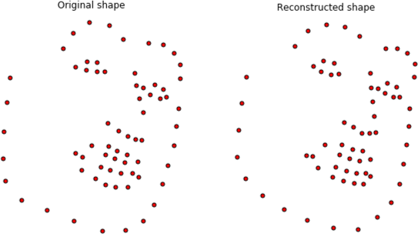

* **Chapter 3: Requirements and analysis:**

**3.1 Functional Requirements:**

**3.1.1** **Admin requirements:**

* **The system has to enforce the administrator to sign in.**
* **The system shall allow only the administration to update the database.**
* **The system shall allow only the administration to assign service provider and customs members.**
* **The system shall allow only the administration to monitor the whole changes made by the service provider in the data.**

**3.1.2** **service provider:**

* **The system has to enforce service provider to sign in.**
* **The system shall allow the service provider to view their products.**
* **The system should enable service providers to update some products.**
* **The system should notify the service provider about any order from the customer.**

**3.1.2Customers:**

* **The system has to enforce customer to sign in.**
* **The system shall allow the customer to view the products.**
* **The system shall notify the customer of new products.**
* **The system allows the customer to cancel the order within 6 hours of ordering the product if he so desires.**

**3.2 Non-Functional requirements:**

**3.2.1 Usability:**

* **The system must be user friendly and easy to deal with.**
* **The installation and maintenance process should be not complex**
* **The system should be easy to learn by any intended users.**

**3.2.2** **Security:**

* **Only the person who has a user name and password can access the app.**
* **The password must be greater than or equal to eight characters.**
* **No one can change the password without login into the app.**
  + 1. **Performance:**
* **The system should perform user tasks within 2 to 3 seconds.**
  + 1. **Maintainability:**
* **The system should be able to cope with new requirements.**
  1. **Software requirements:**

|  |  |
| --- | --- |
| PyCharm 2019 | used to write the codes of the python |
| Sketch | **used in designing the user interface** |
| StarUML | **used to make UML diagrams** |
| Microsoft office project | **used to schedule the project plan** |
| Microsoft word | **used in doing the project assignments** |
| Microsoft PowerPoint | **used in doing the presentation** |
| Microsoft excel | **Used in making tables and some charts.** |

* **Hardware requirements:**

|  |
| --- |
| * Personal computer: * CPU Type: Intel® core ™i7 * RAM: 64 GB * System Type: 64-bits Operating System |

**3.4Conceptual Modeling:**

**3.4.1 Use Case Diagram:**

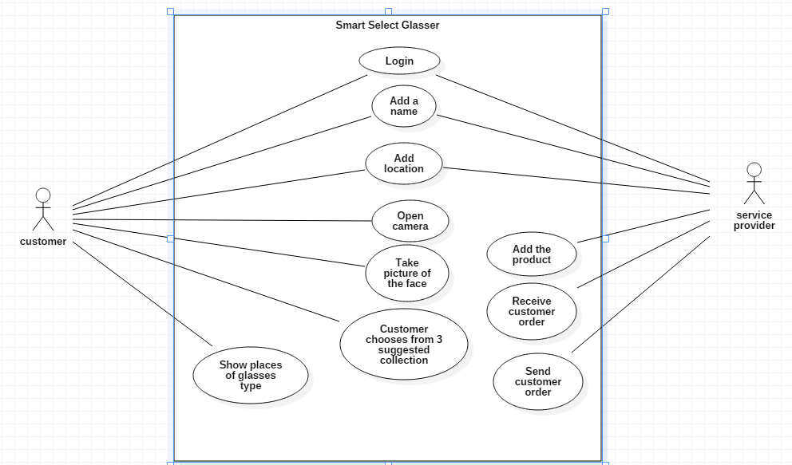

**3.4.2Flowchart diagram:**

|  |
| --- |
| **System verfication**  **Login by name & password**  **Login by name&password**  **Open App**  **Open system web site**  **Service provider**  **Customer**  No No  **System verfication**  yes yes  **Sign out**  **Receive the request and send the order to customer**  **Send the request to the service provider**  **DataBase**  **Chose from 3 Product**  **Enter face photo**  **Add Product** |

**3.5 Activite Digram:**

**3.5.1 Administrator activity diagram:**

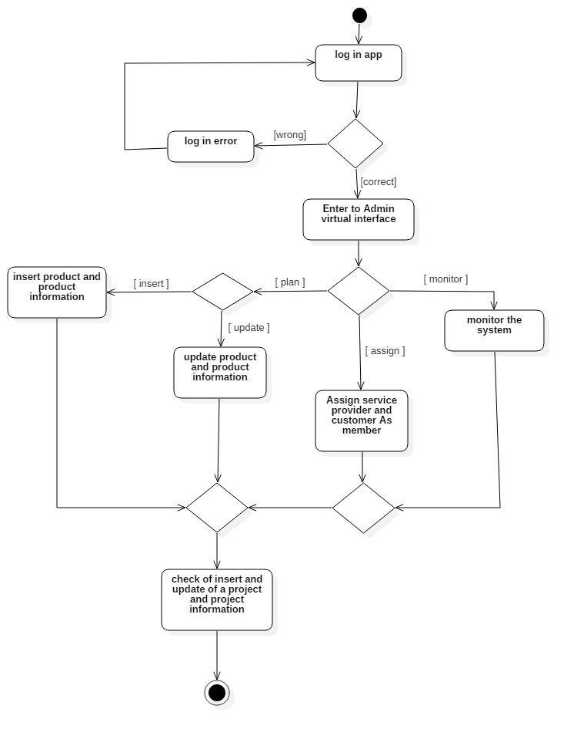

**3.5.2 Service Provider Activity Diagram:**

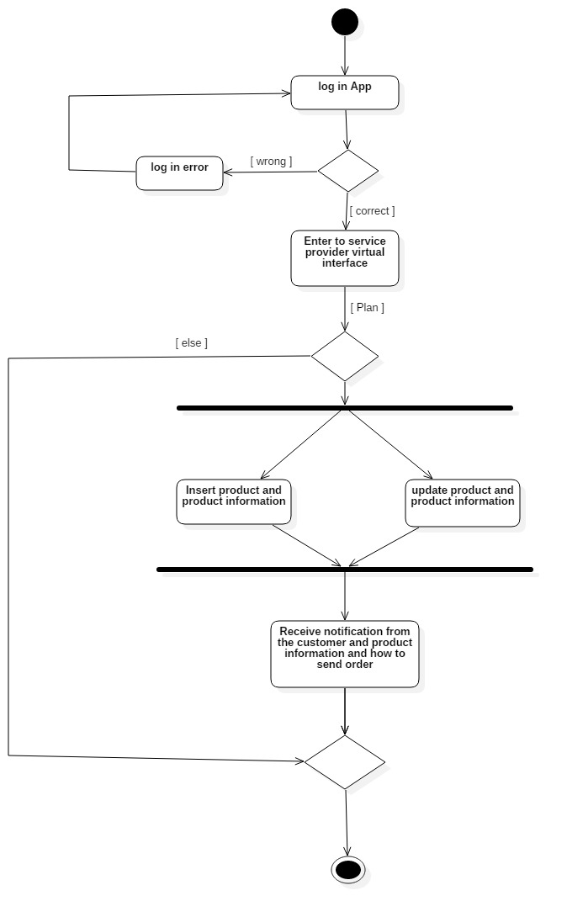

3.5.3 Customer Activite Digram:

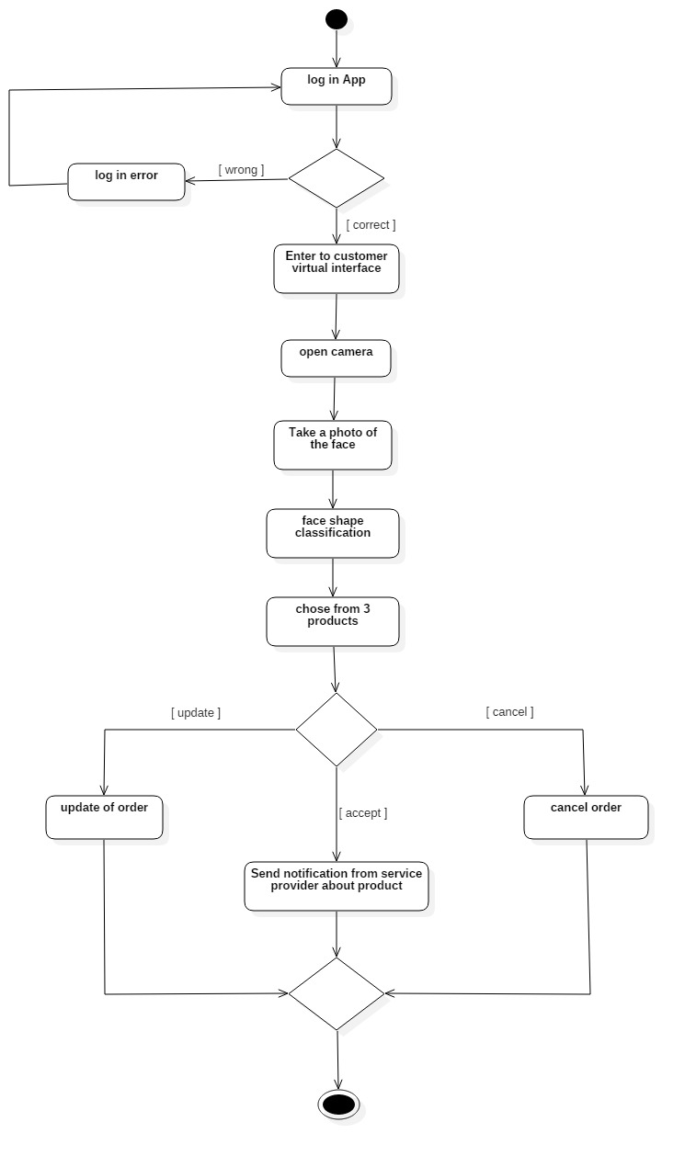

**3.5.4 Sequence diagram:**

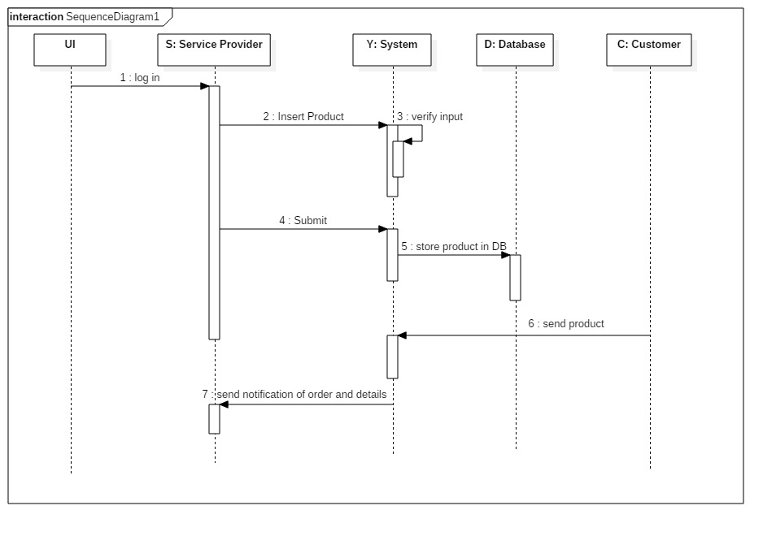

**3.5.6Testing and evaluation:**

**At the end of this chapter, I have considered the requirements test by checking its completeness, clearness, correctness, and consistency. I tried to find any gaps or uncovered cases, check all statements whether it is correct or not, also I removed all ambiguities in the requirements.**

**[ Word count: 2650 ]**

## **Chapter 4:** **Implementation:**

**4.1 Overview:**

**Through this chapter, I will focus on the final design of the user interface, and I will also attach the final code for this program “Smart Select Glasses (SSE)”.**

**4.2 User InterFace:**

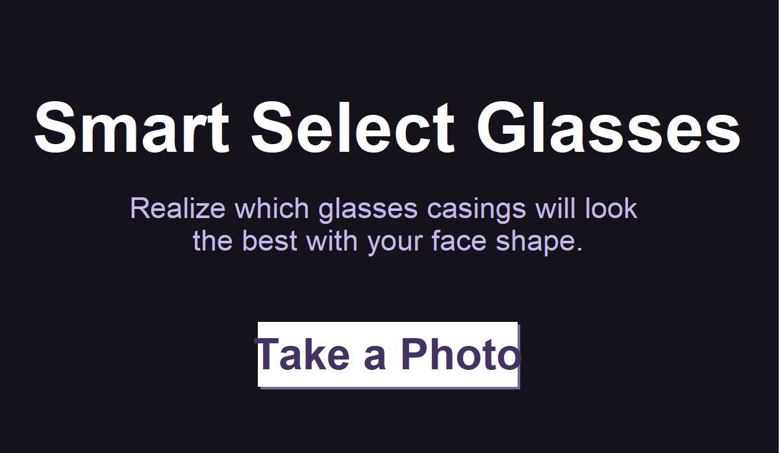

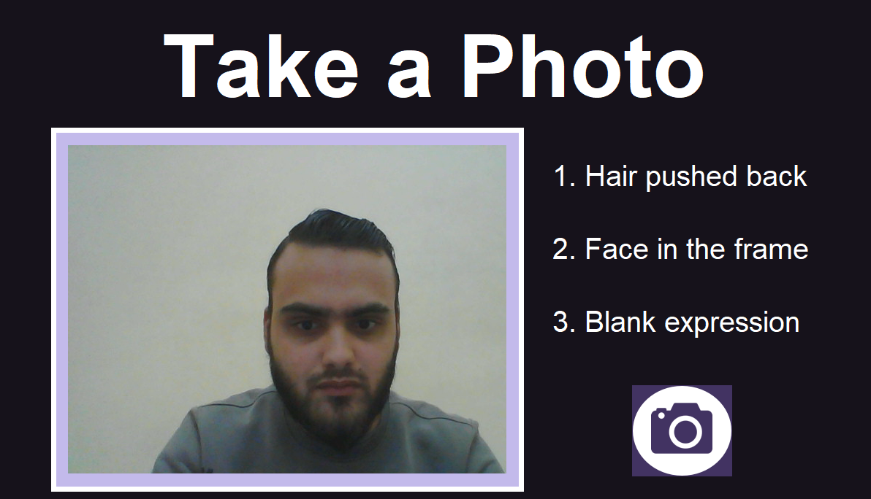

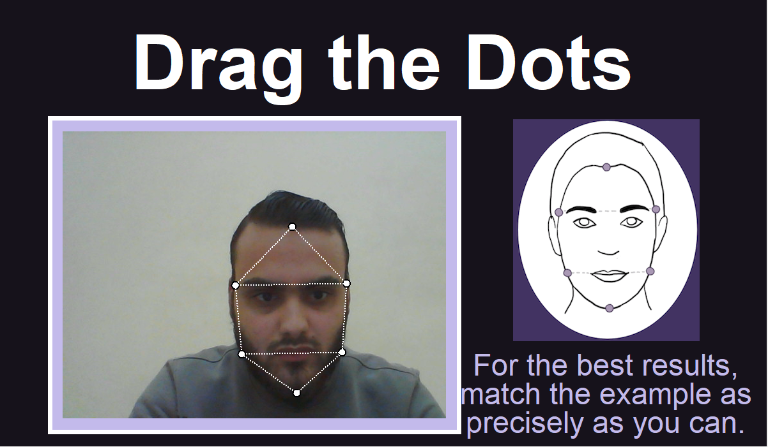

**4.3 APPLICATION SOURCE CODE:**

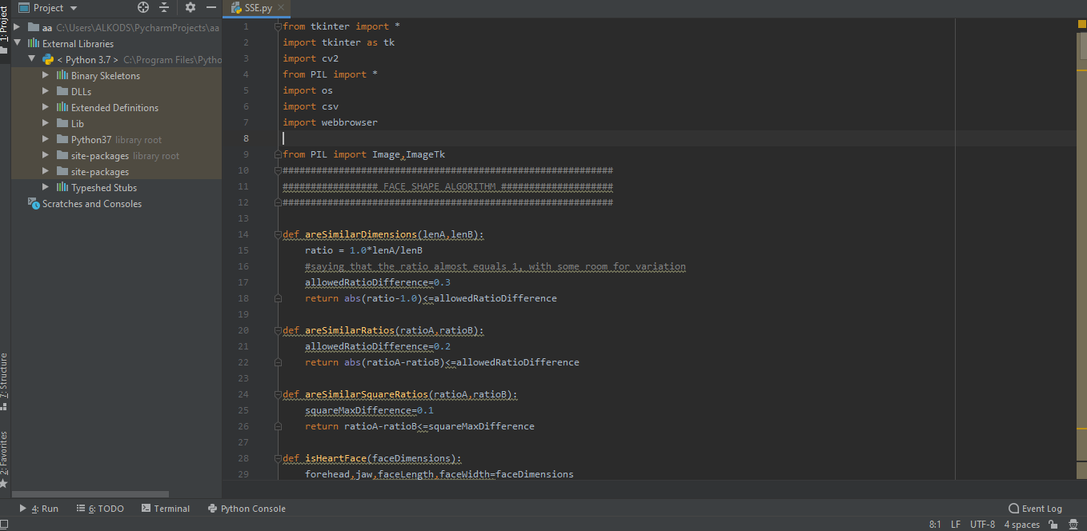

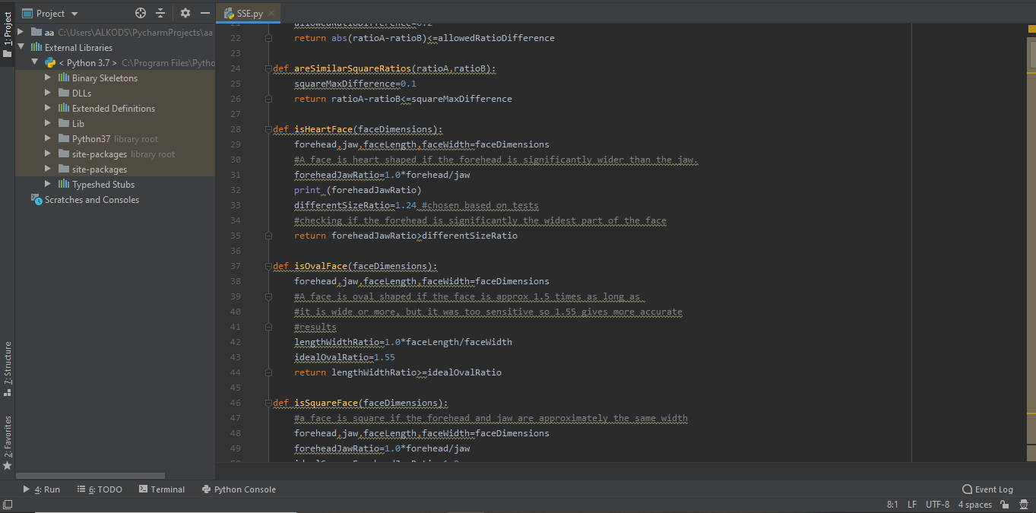

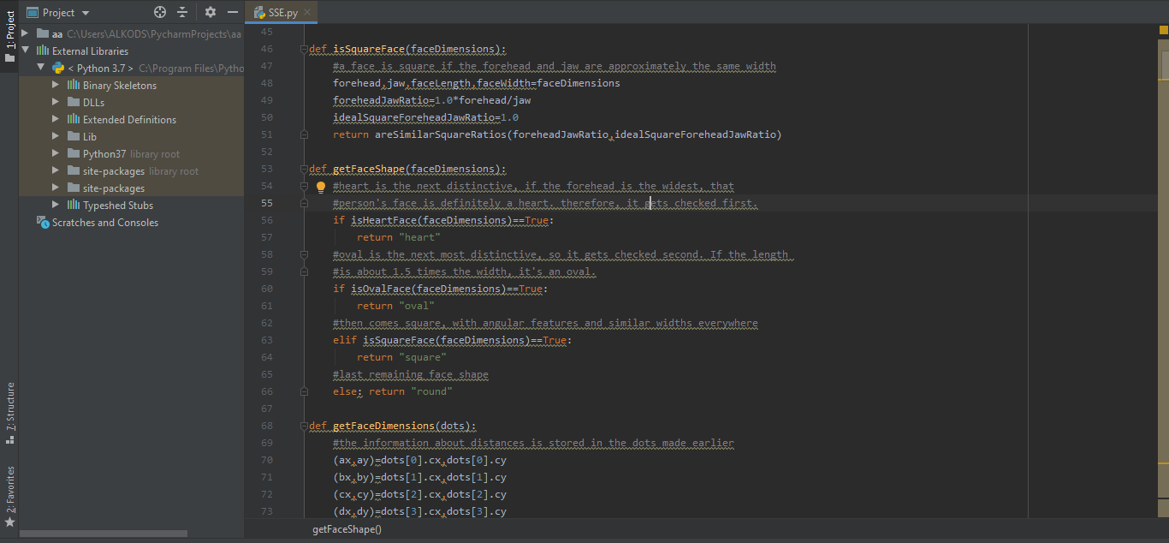

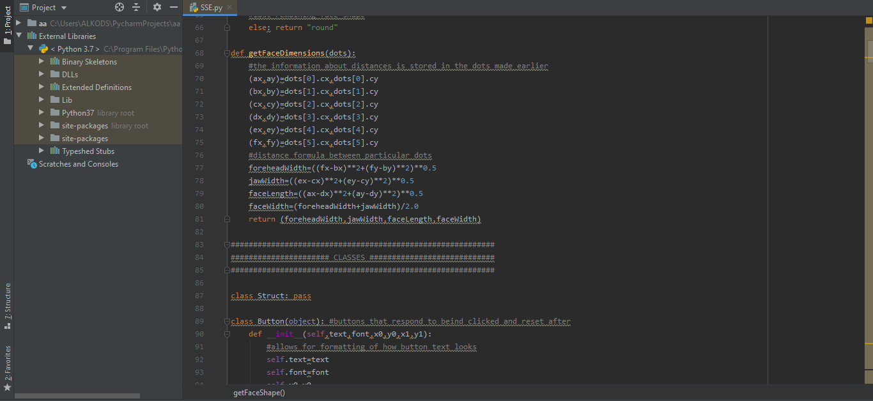

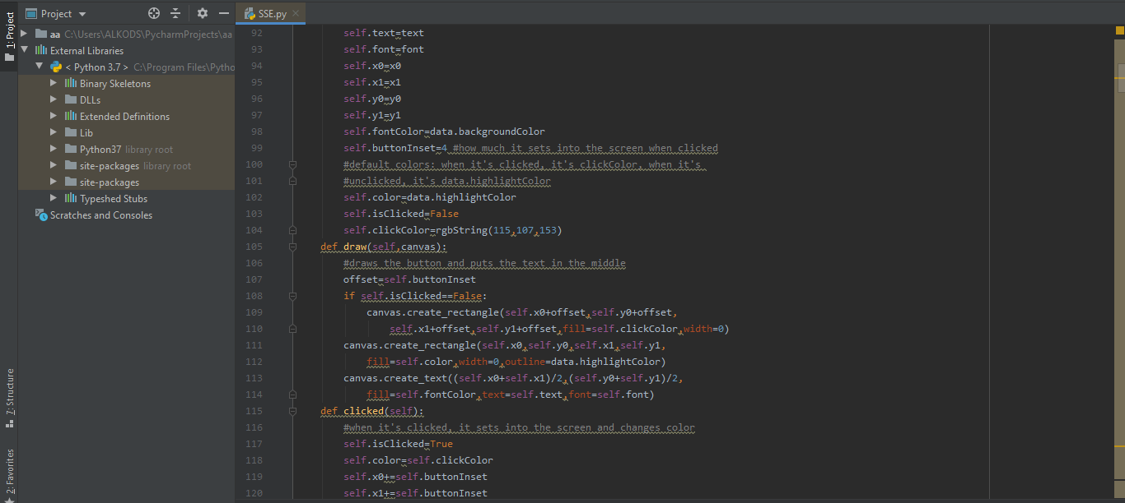

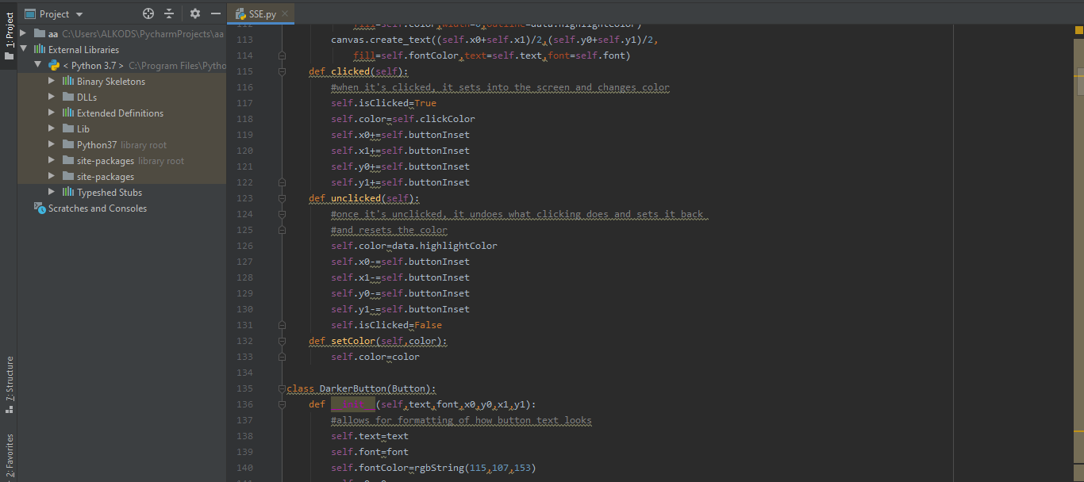

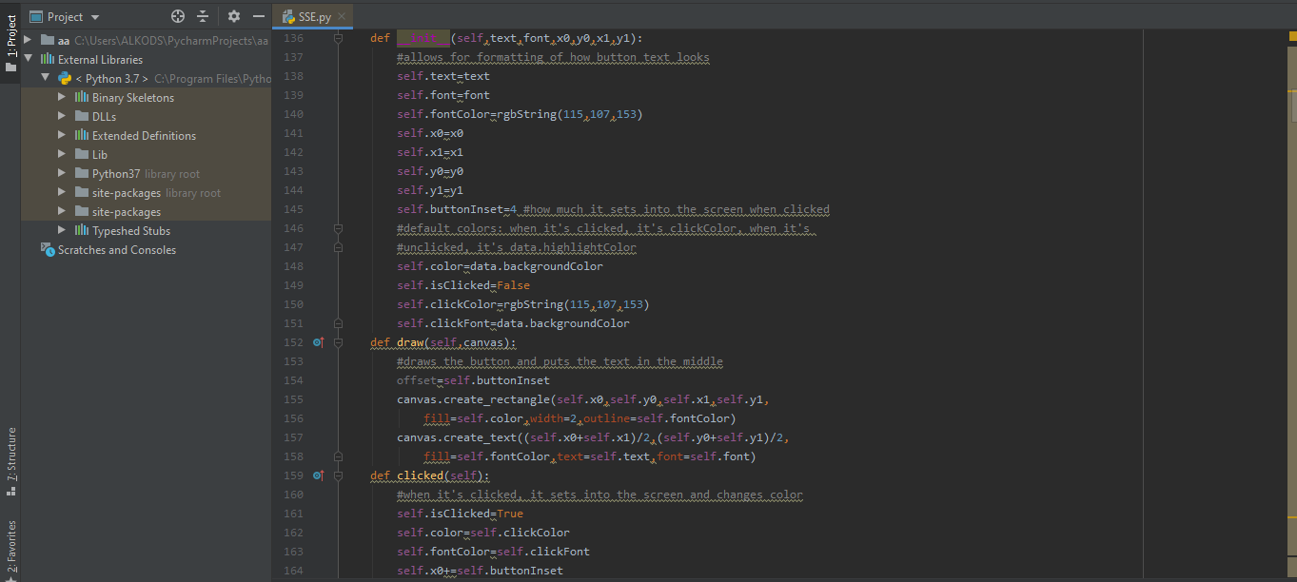

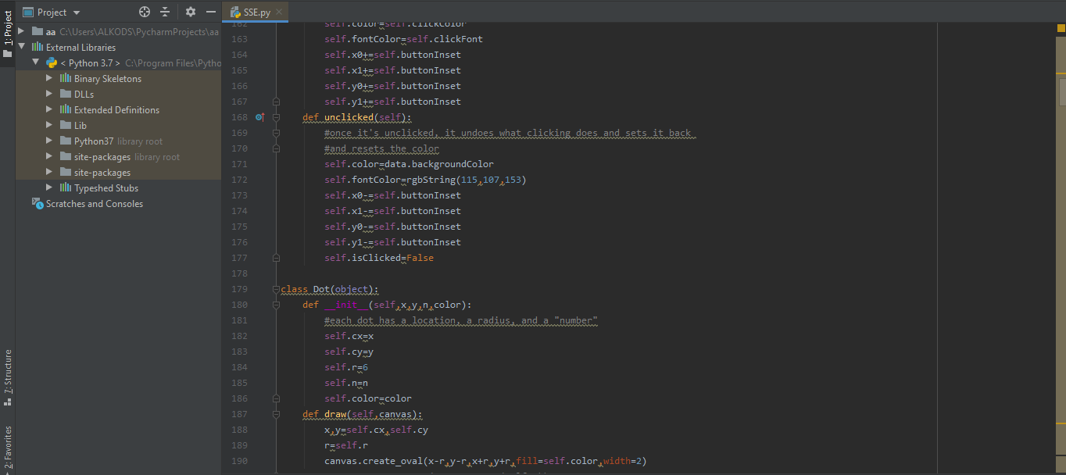

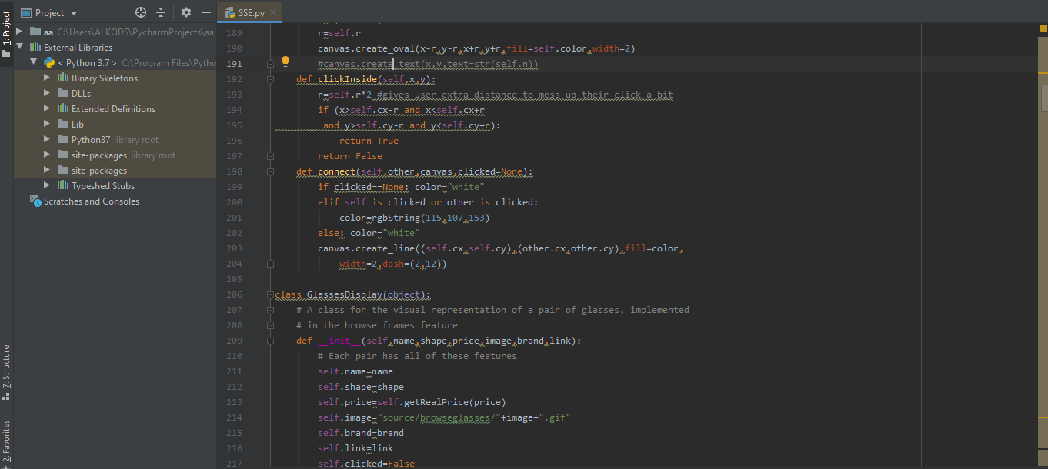

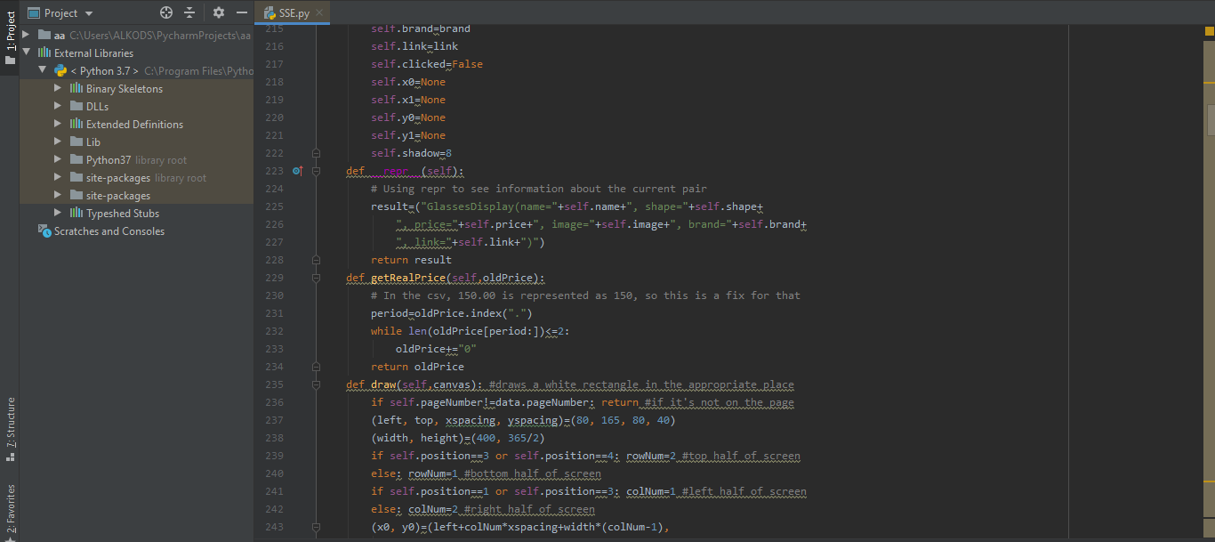

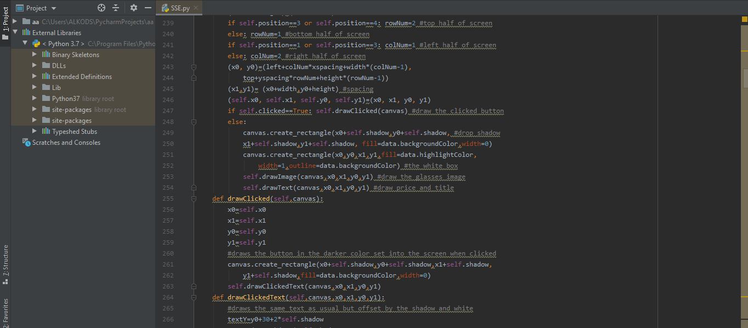

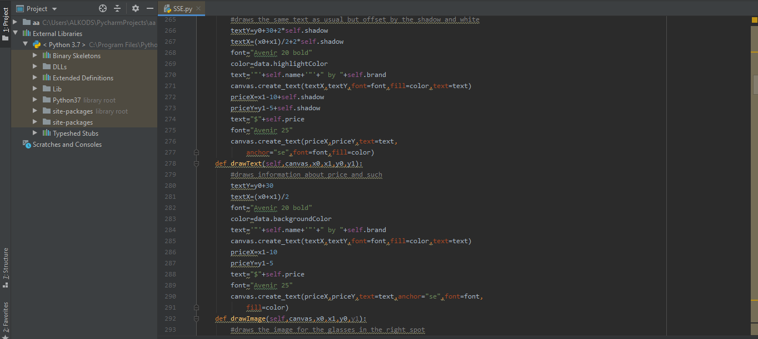

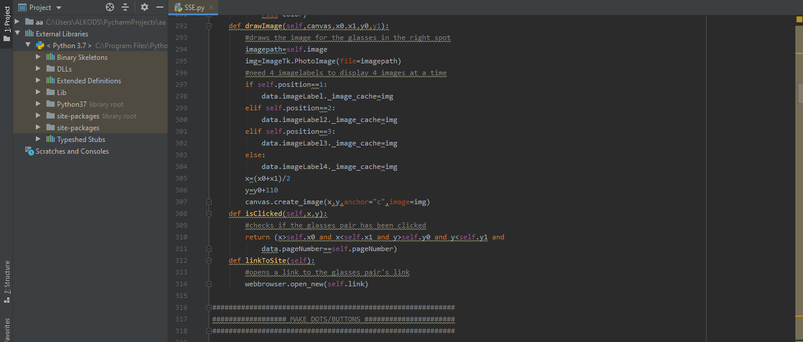

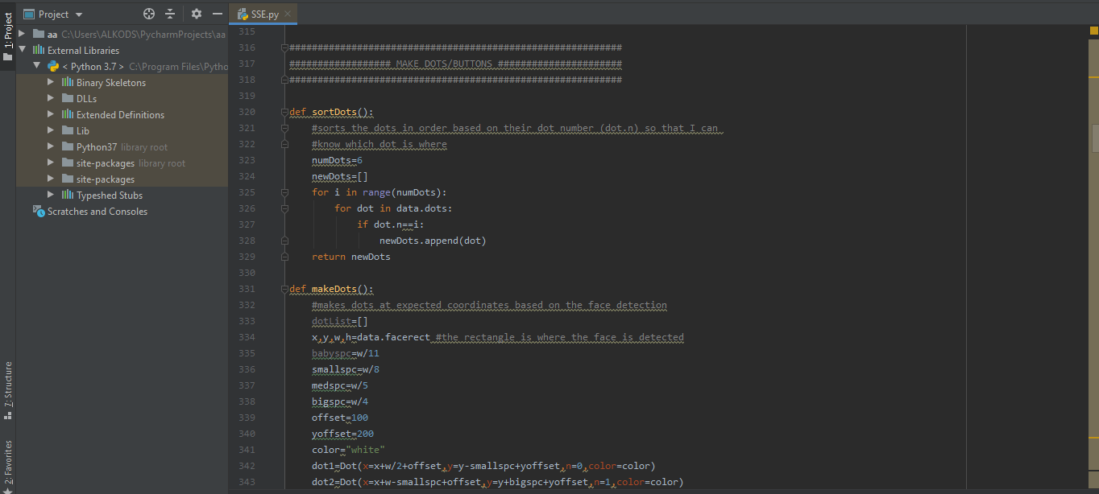

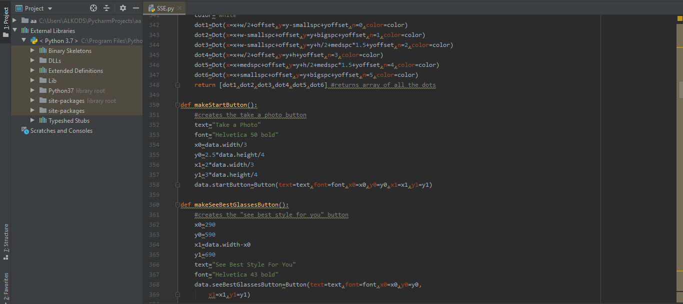

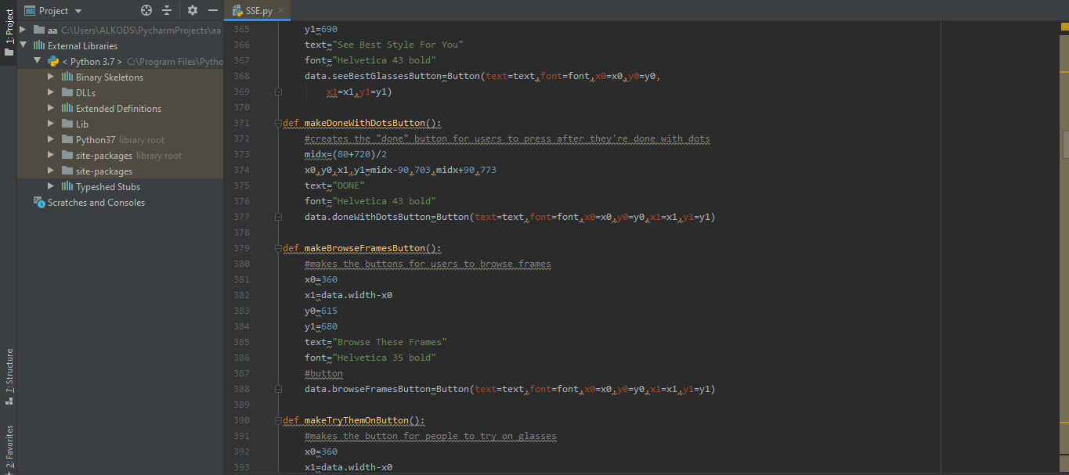

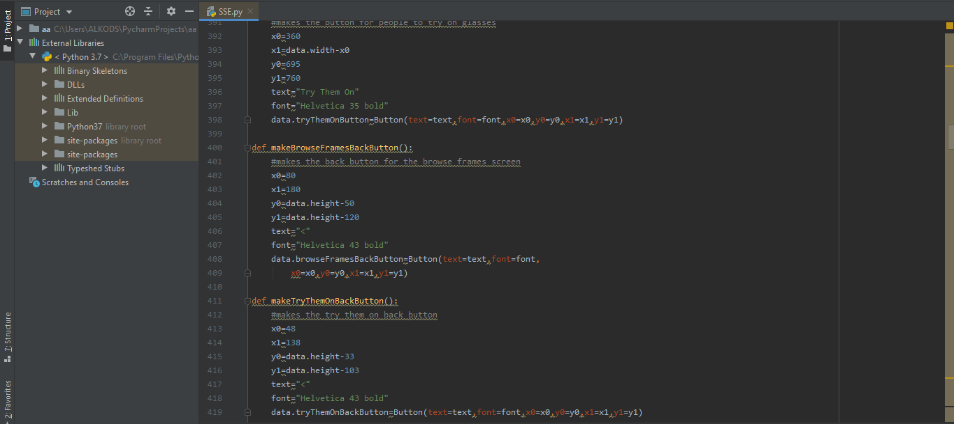

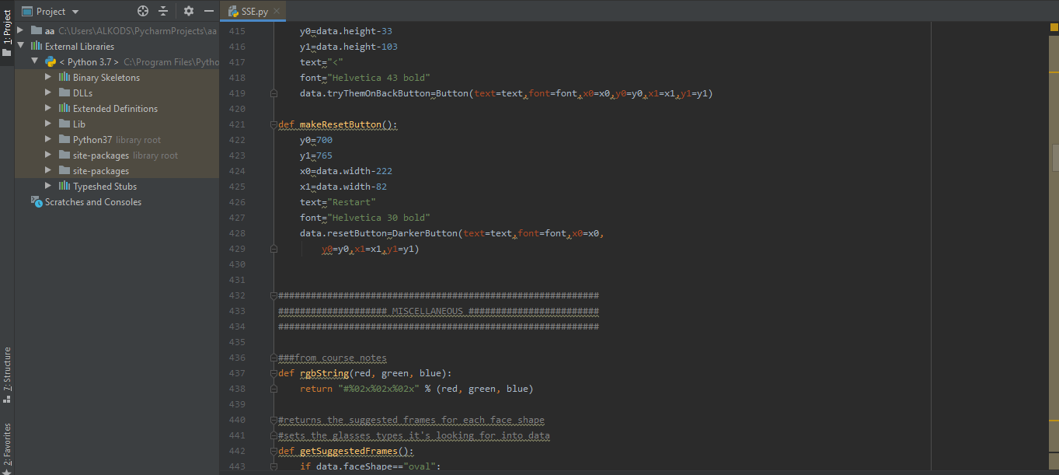

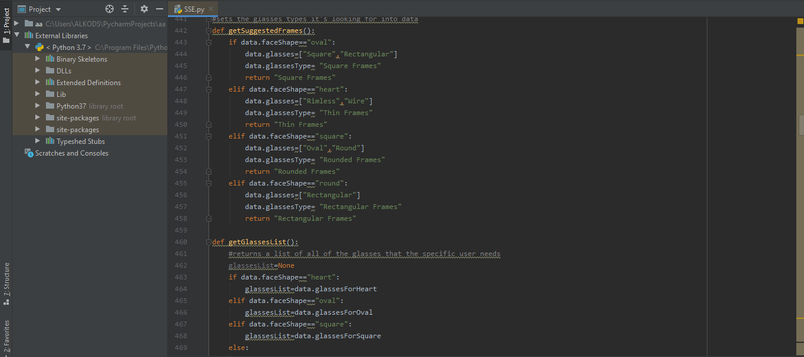

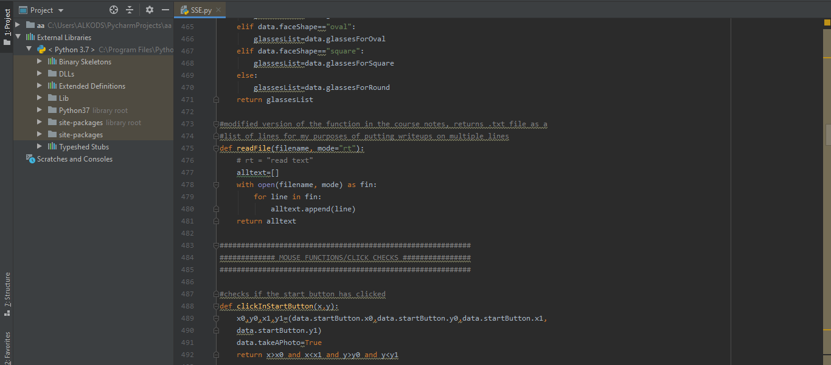

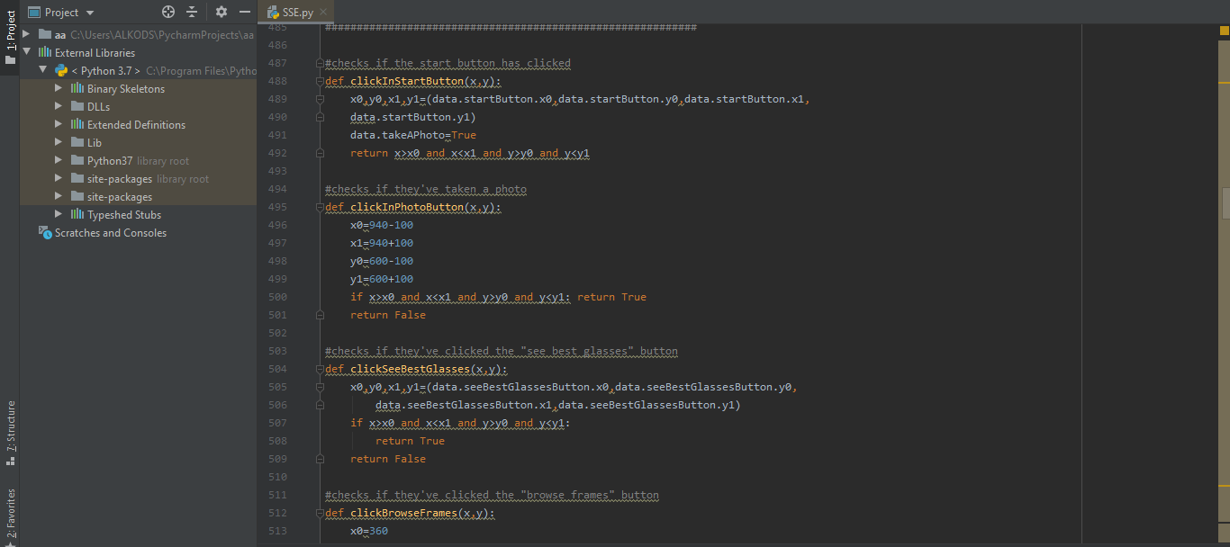

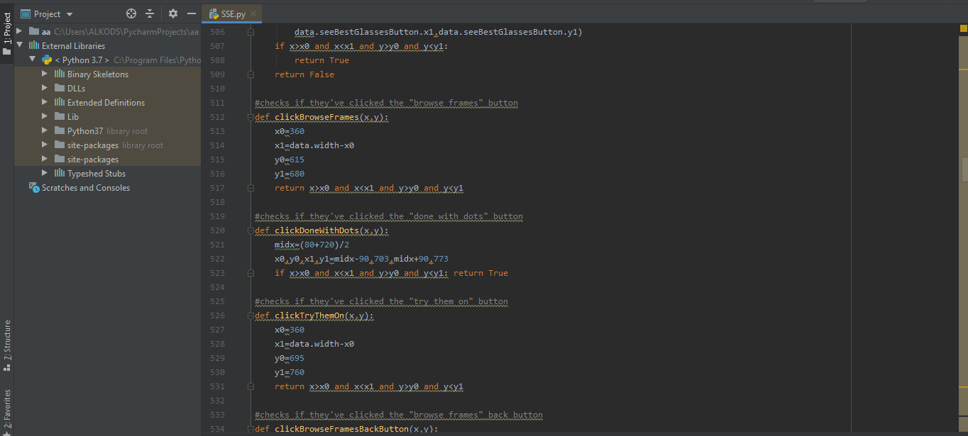

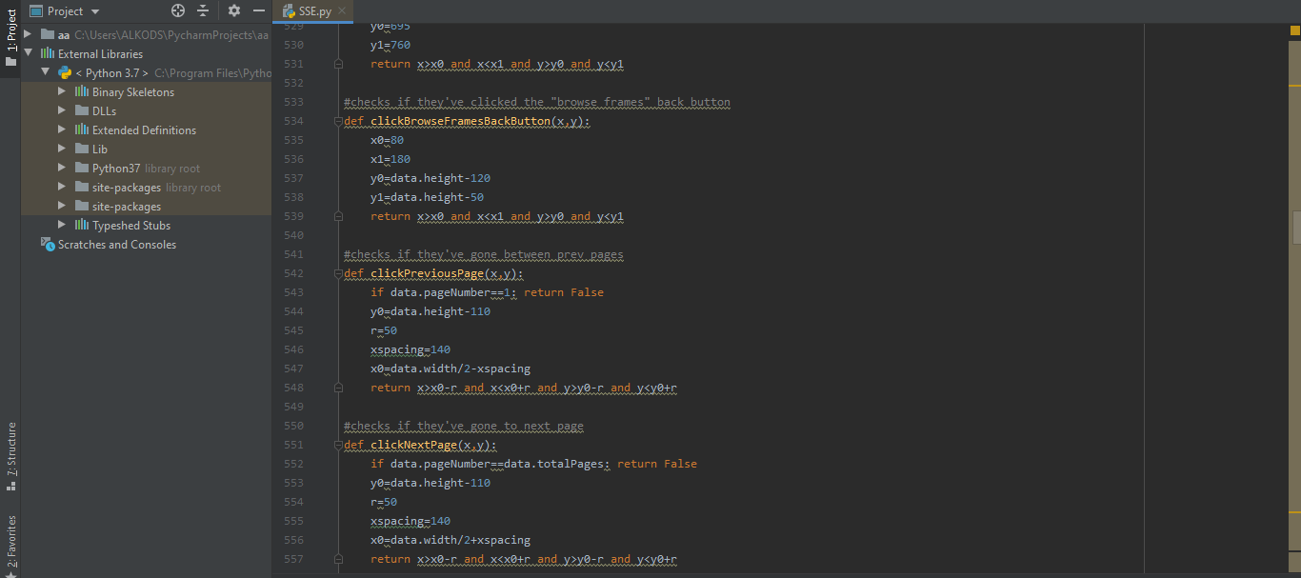

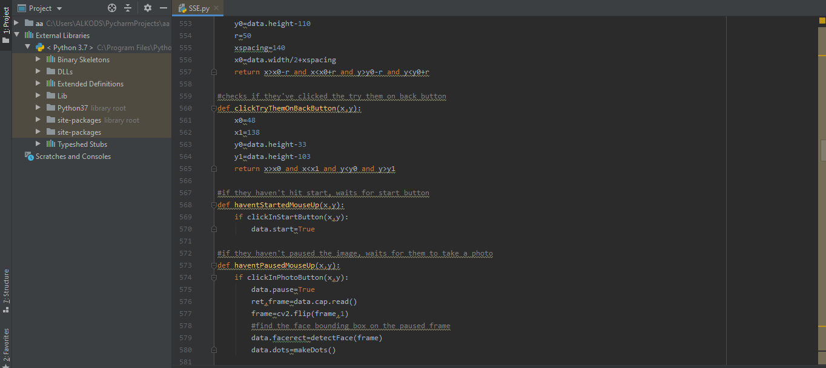

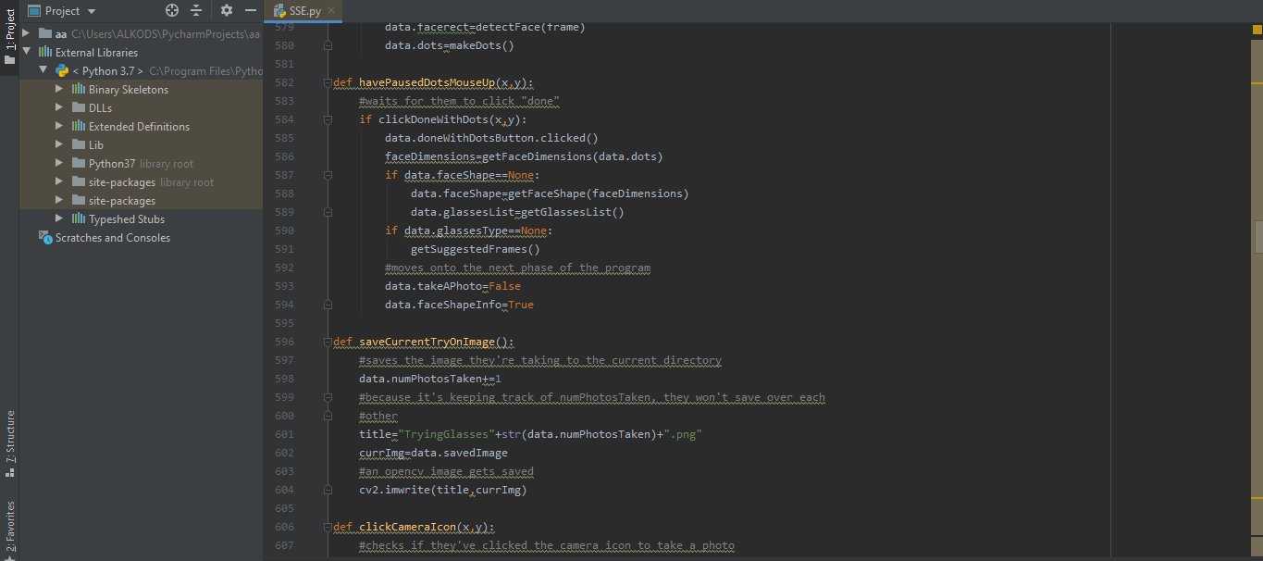

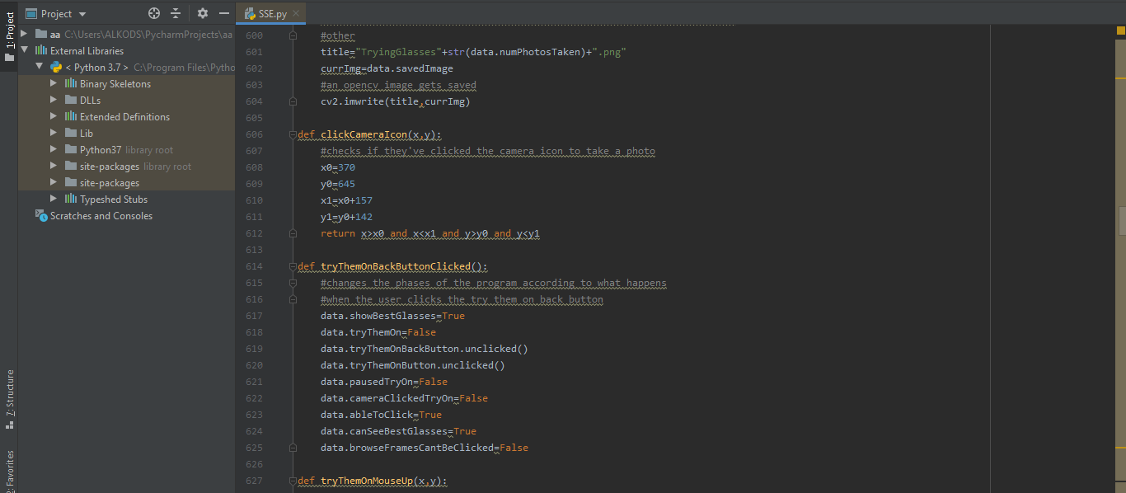

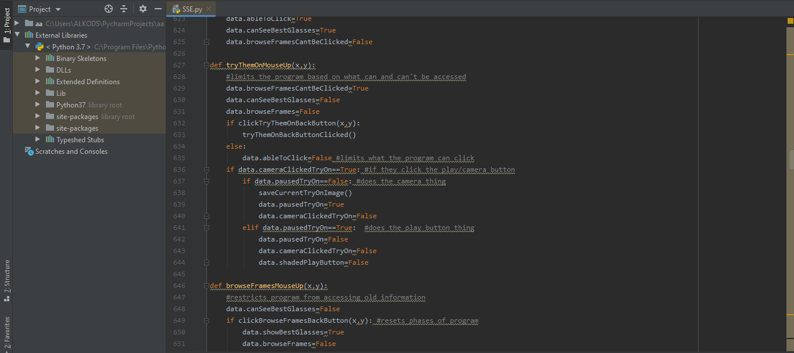

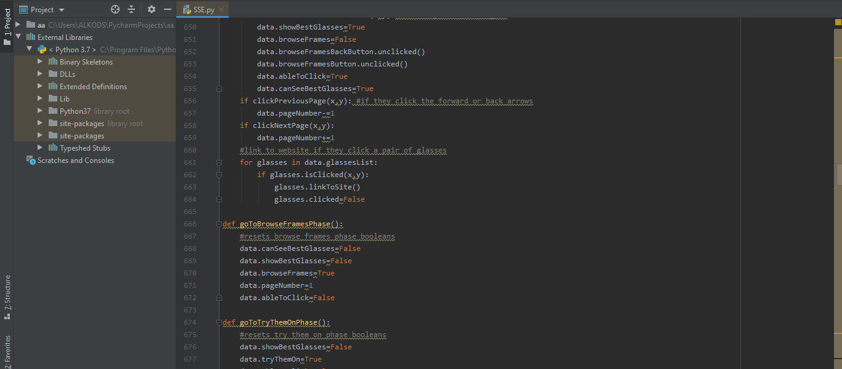

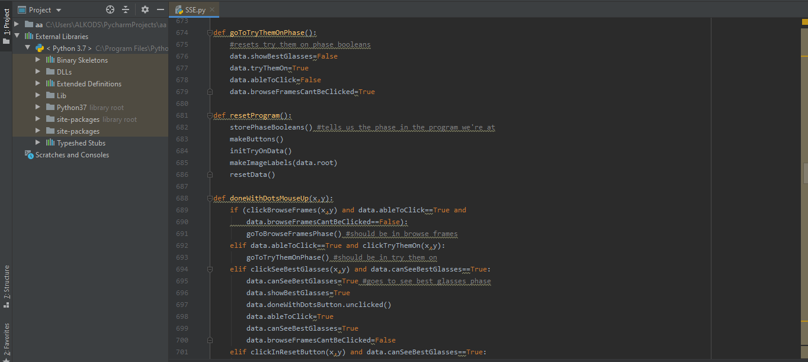

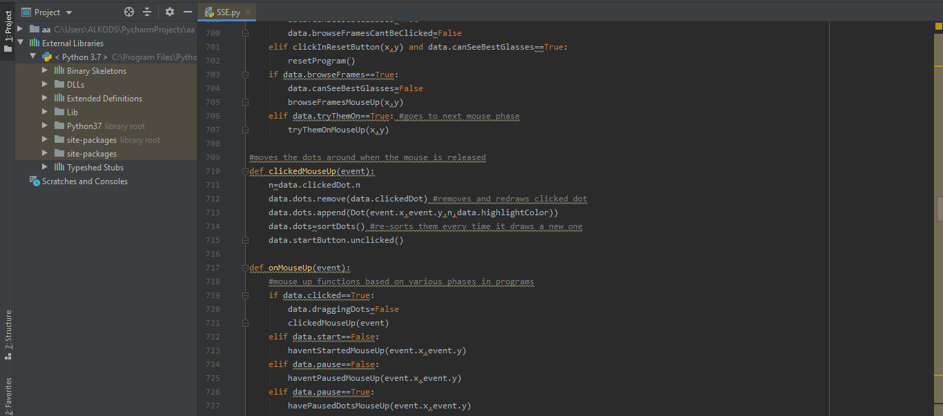

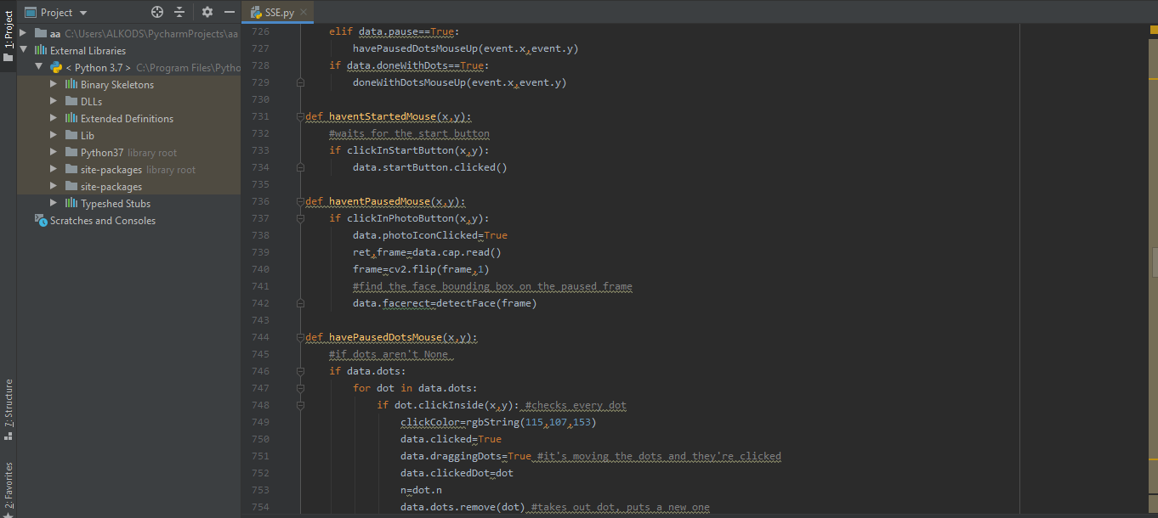

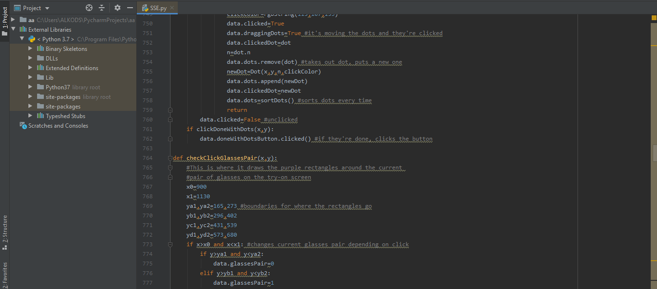

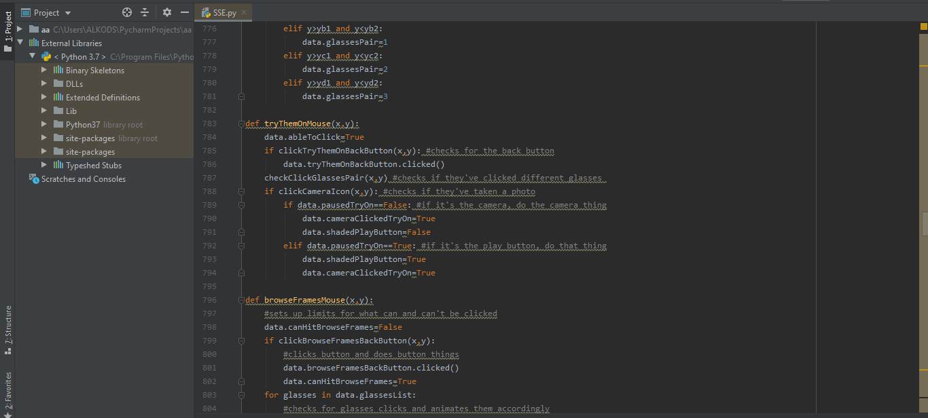

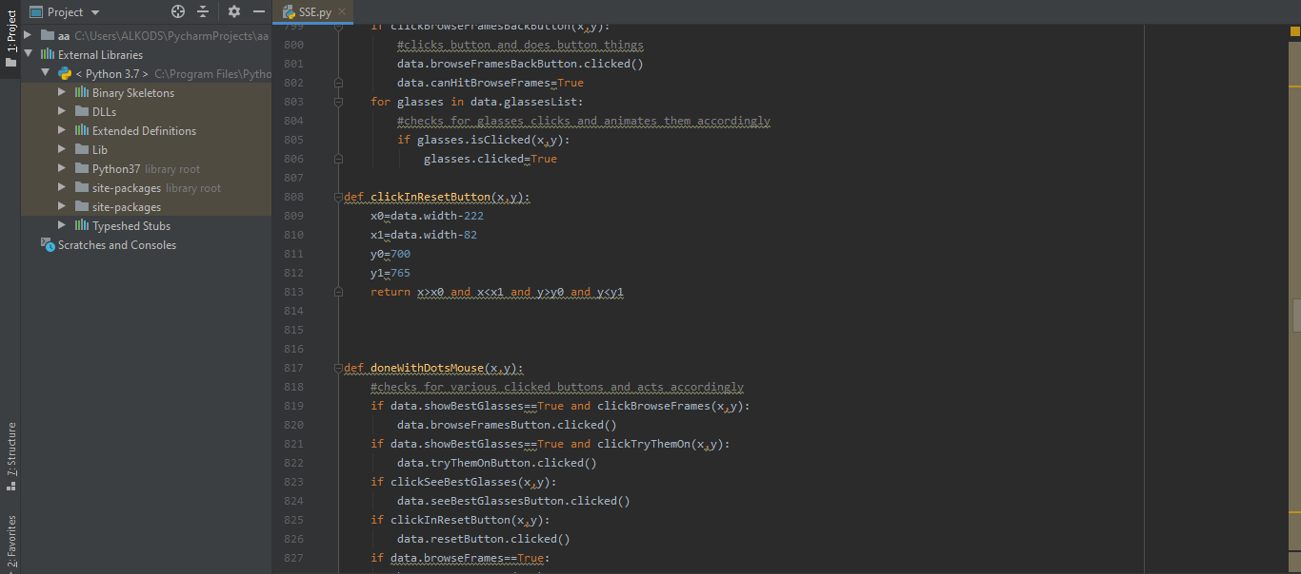

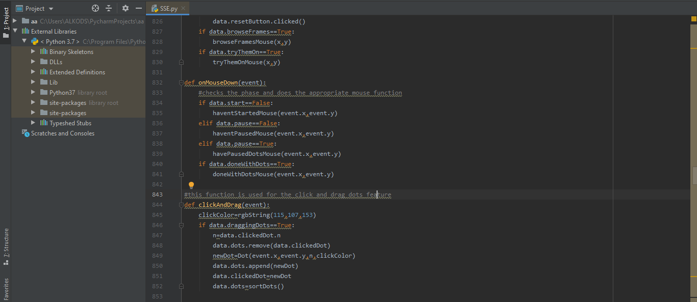

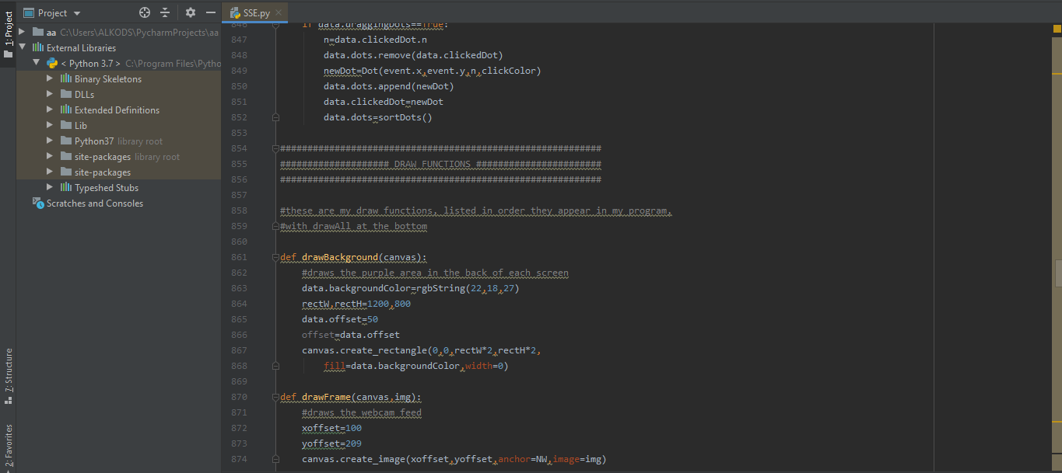

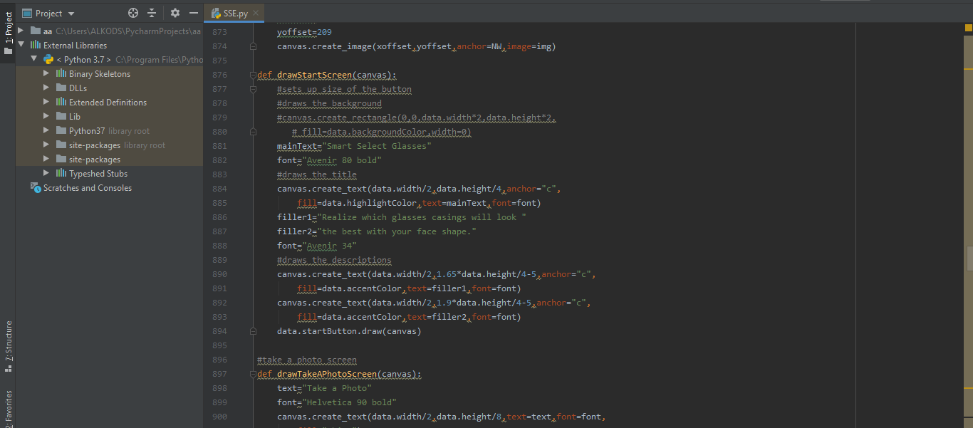

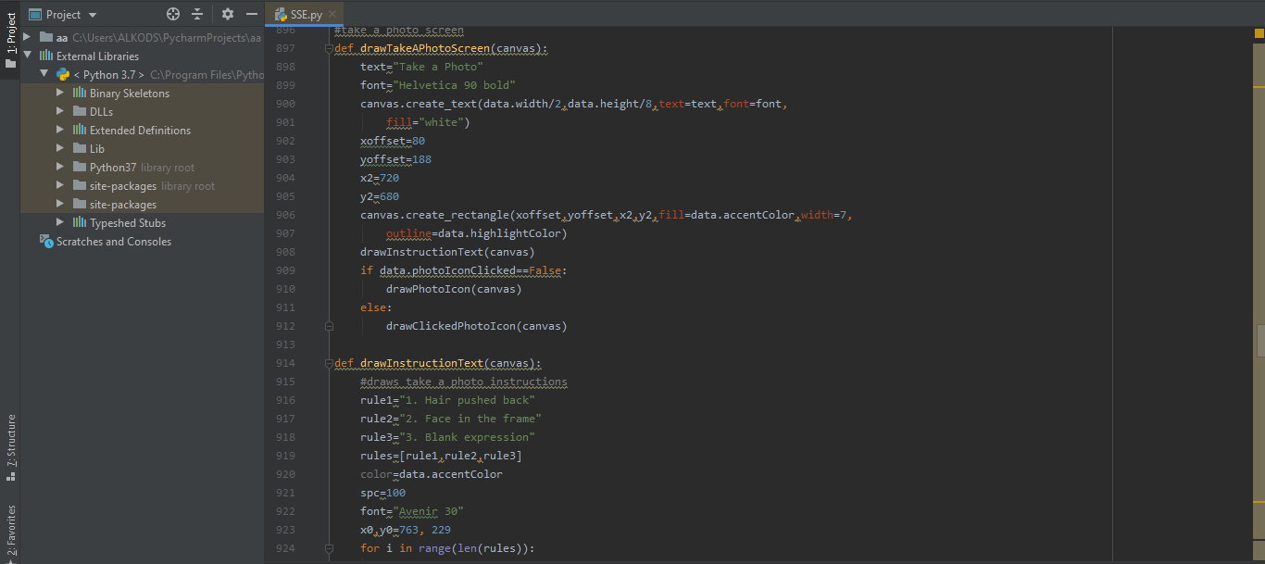

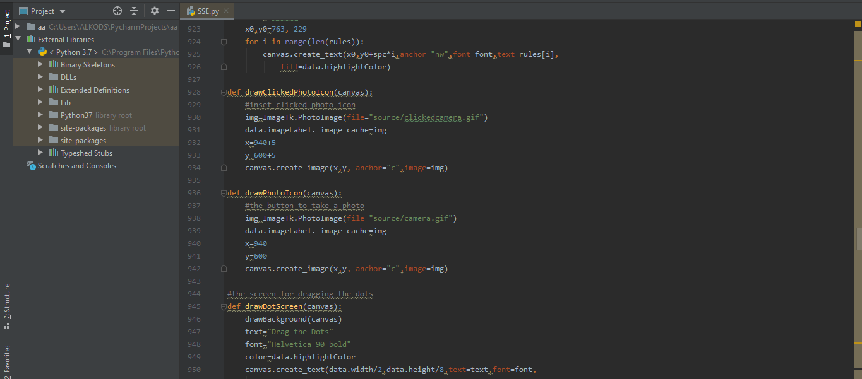

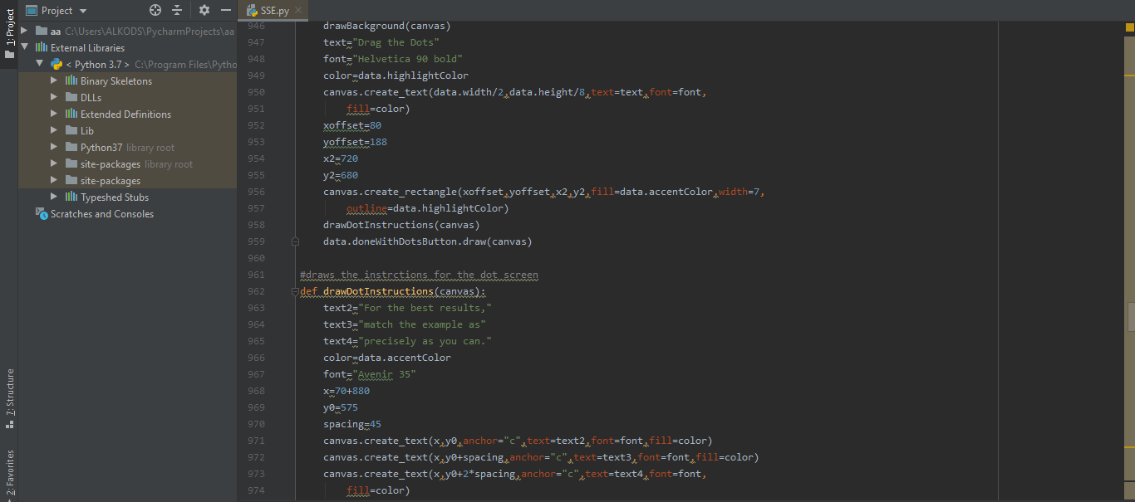

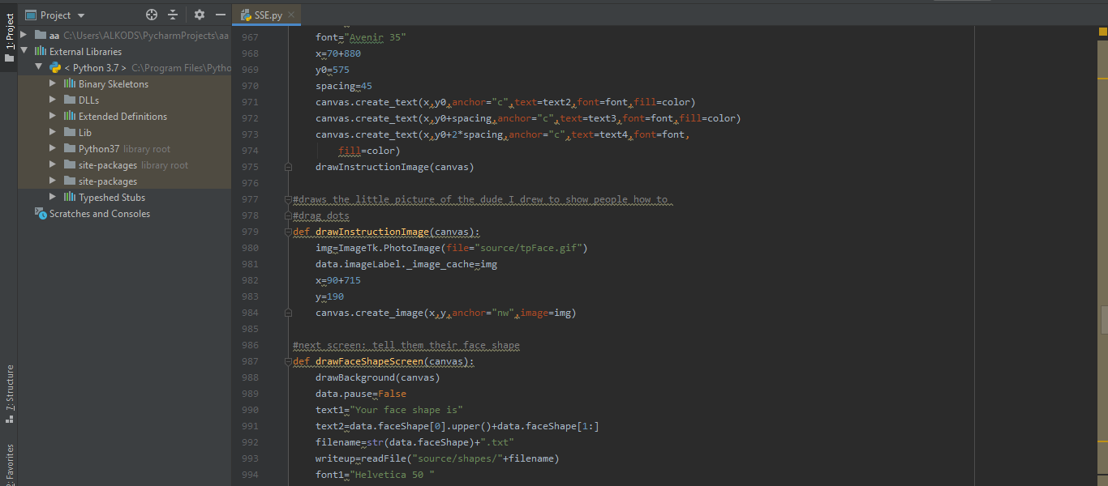

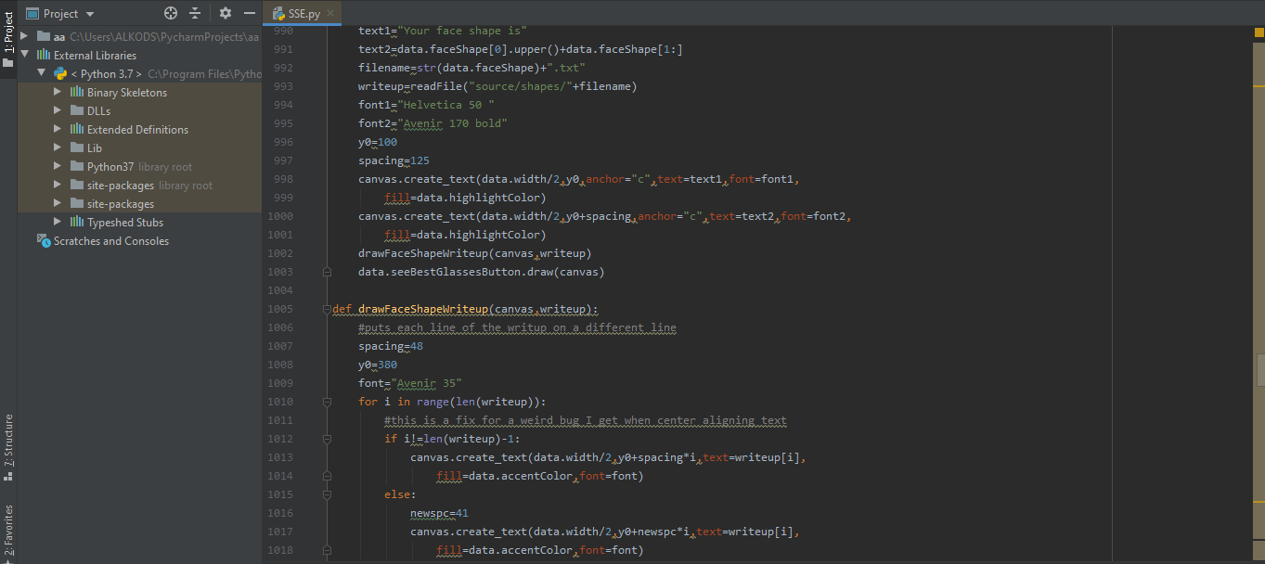

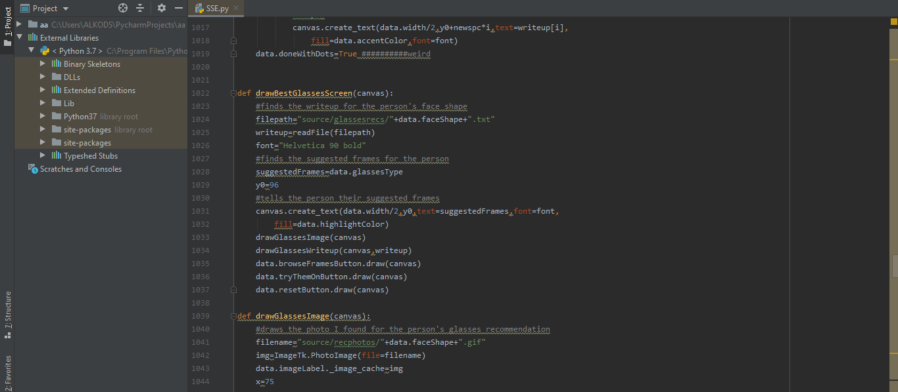

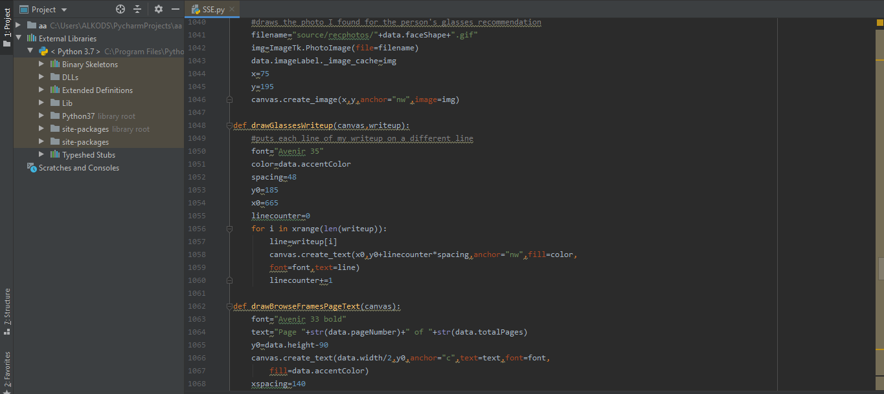

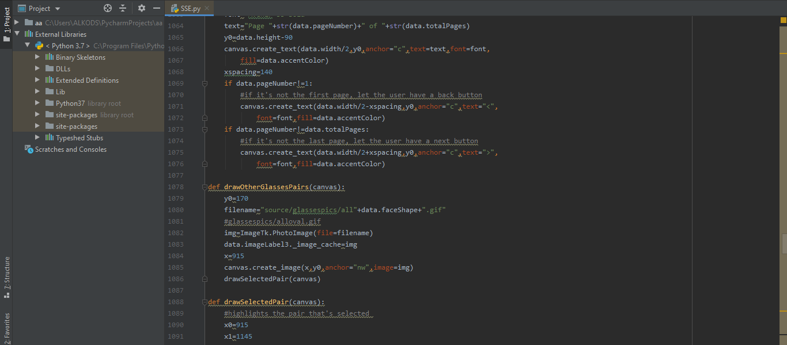

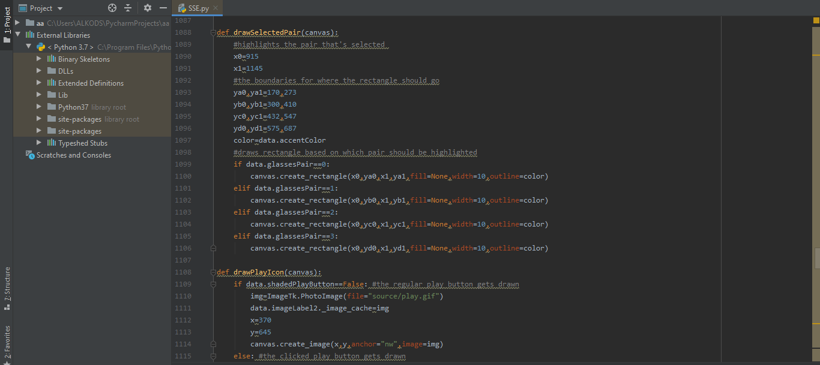

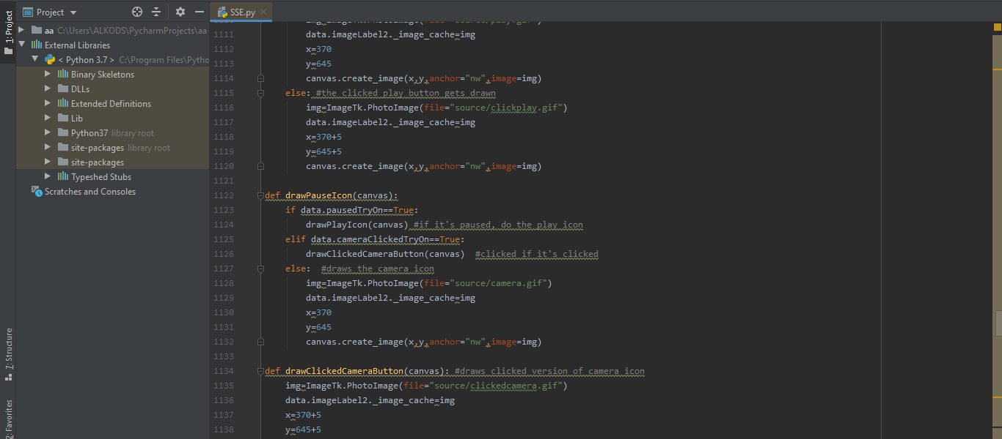

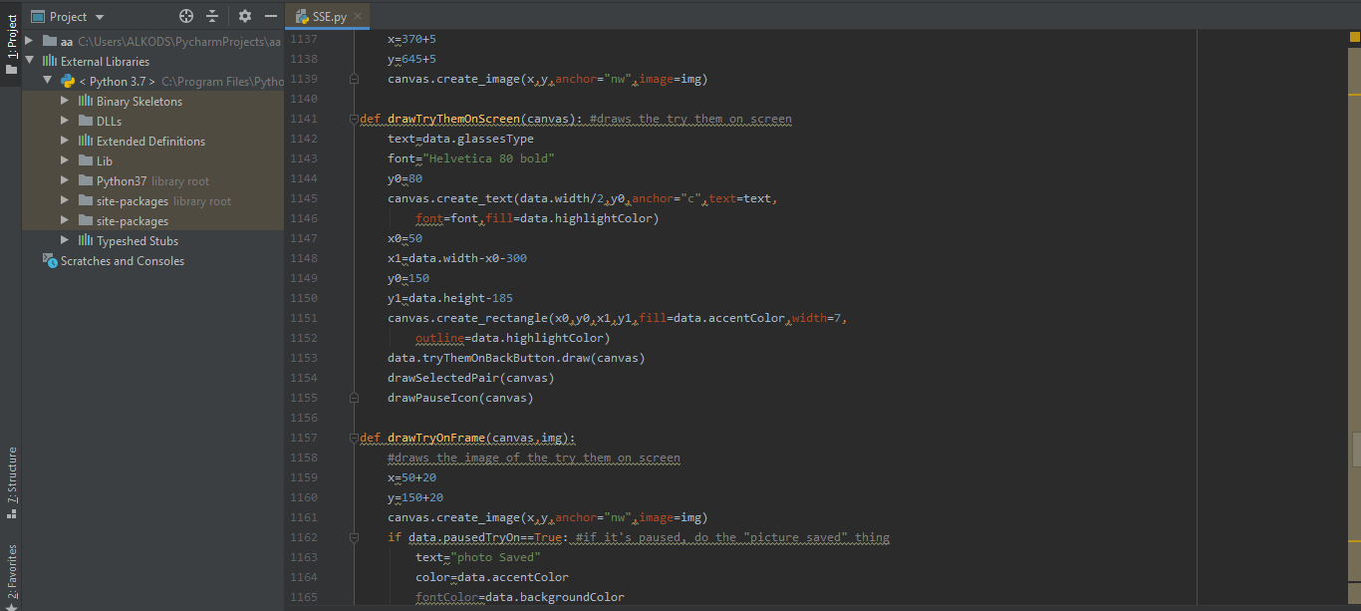

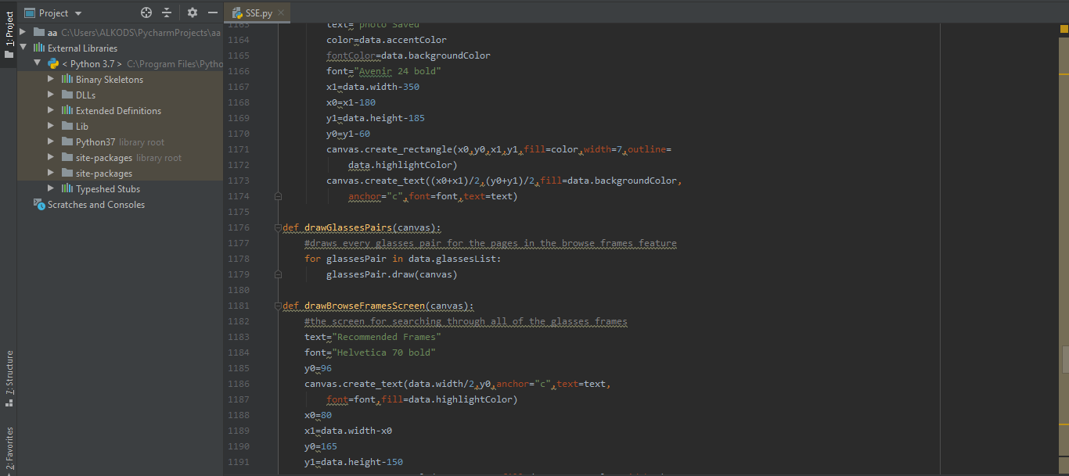

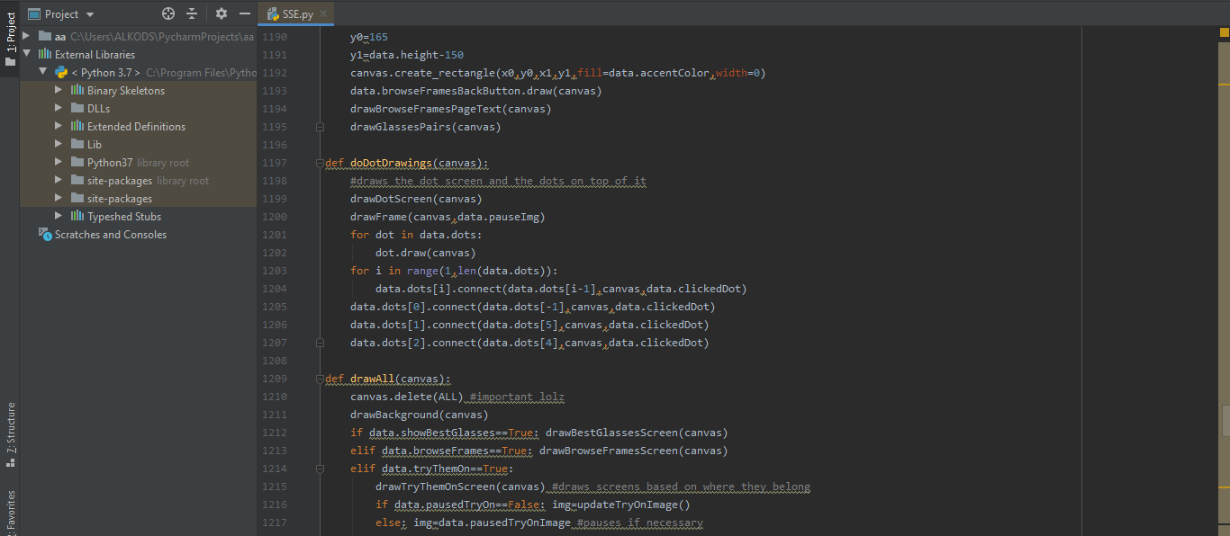

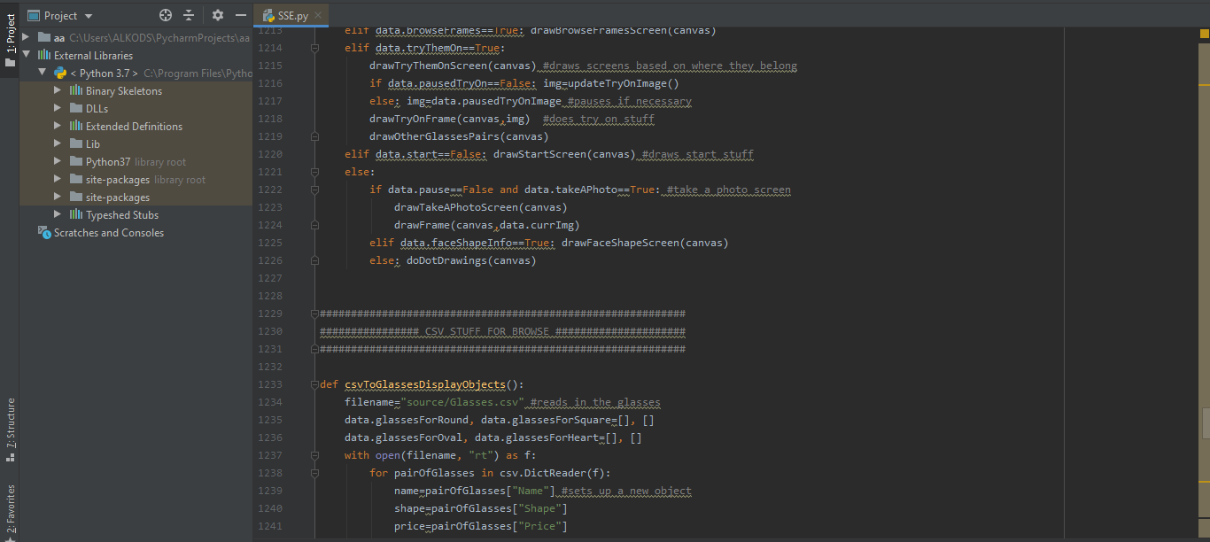

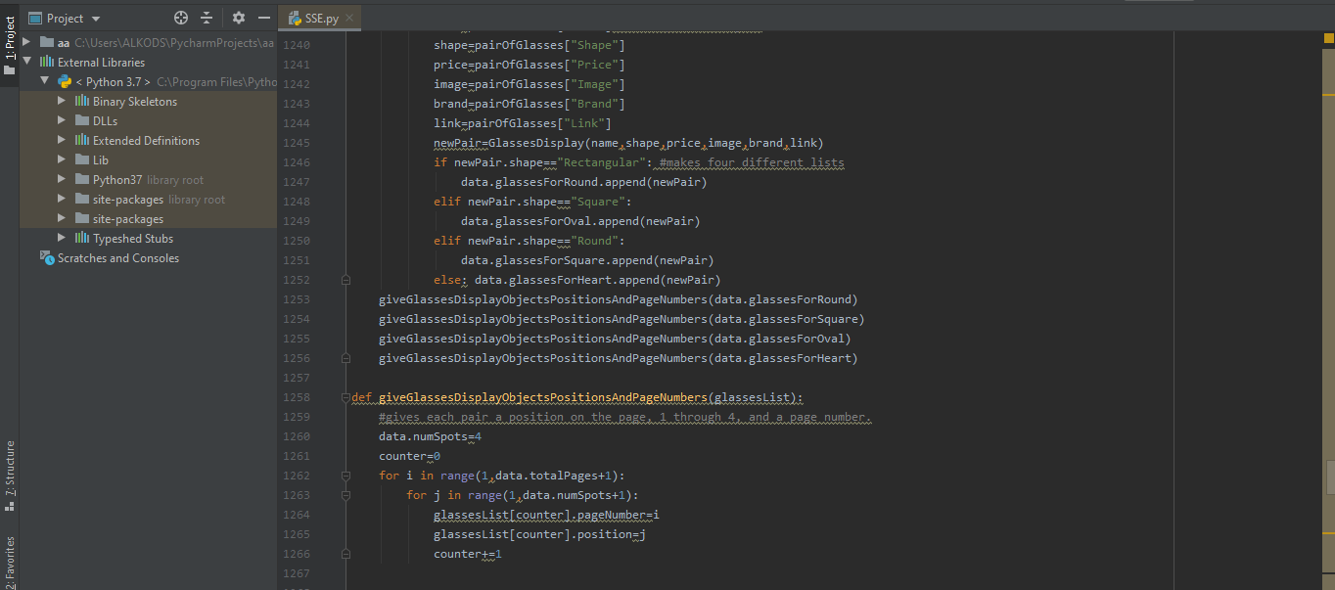

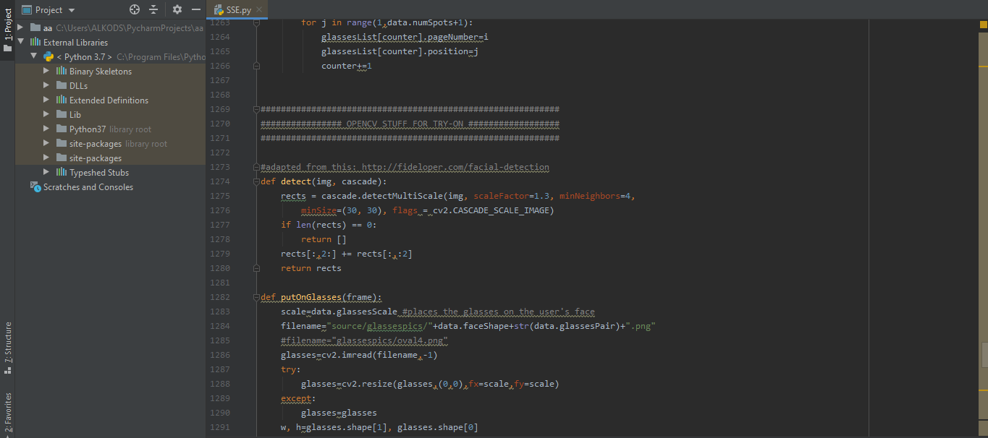

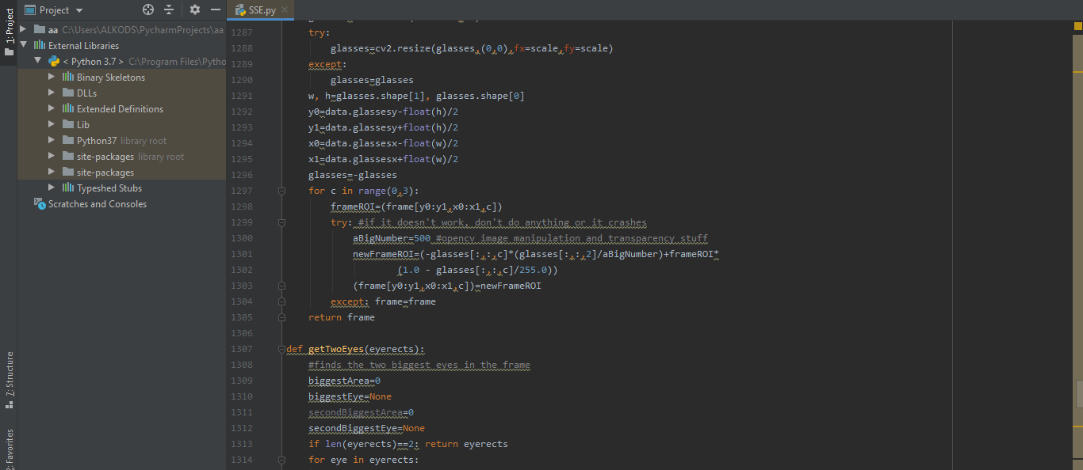

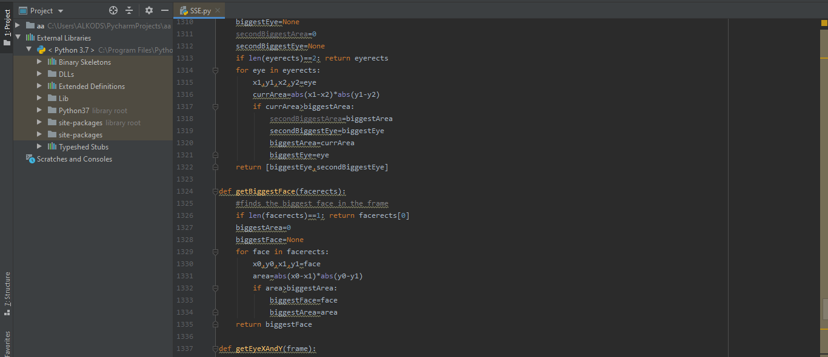

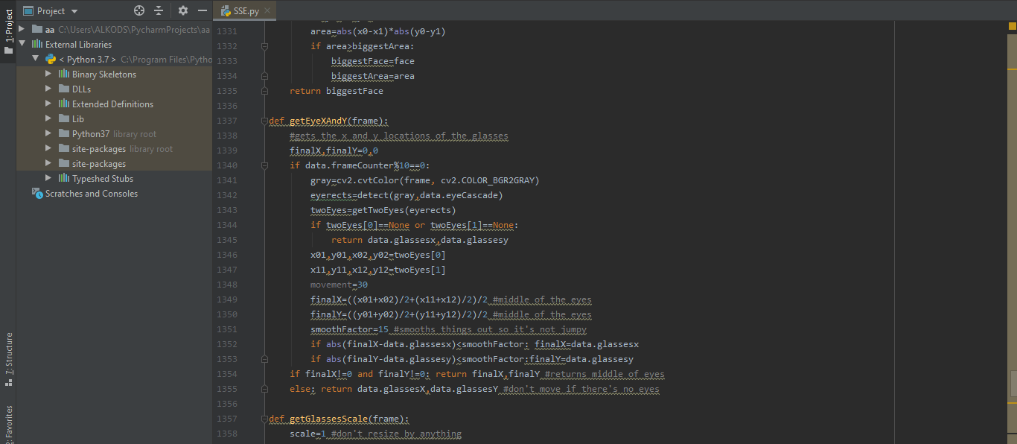

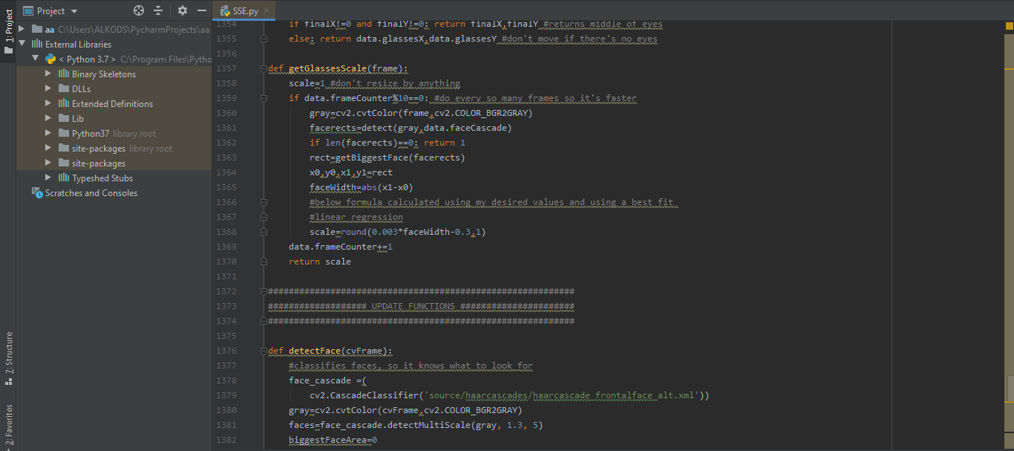

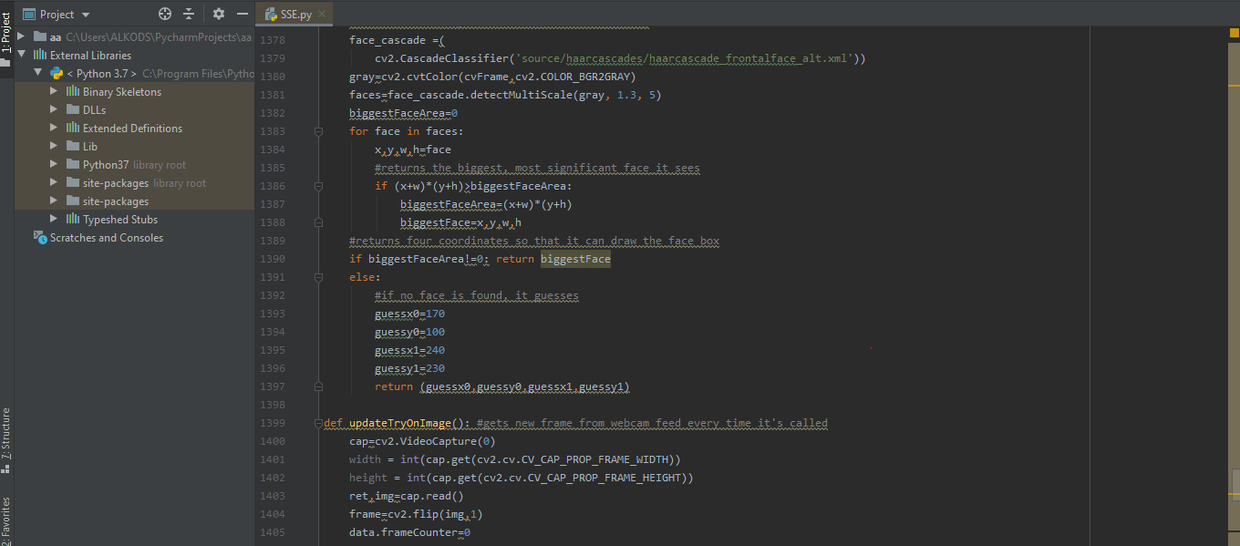

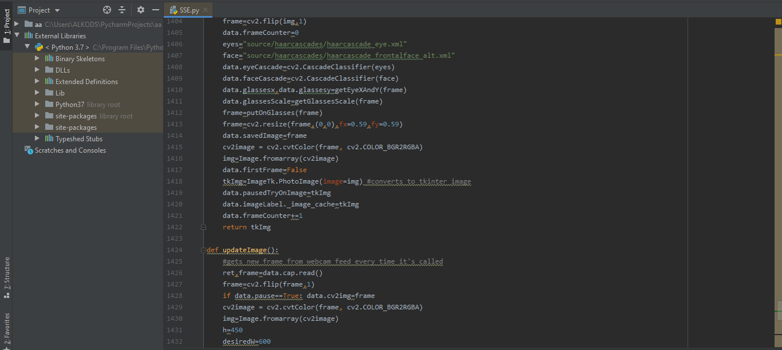

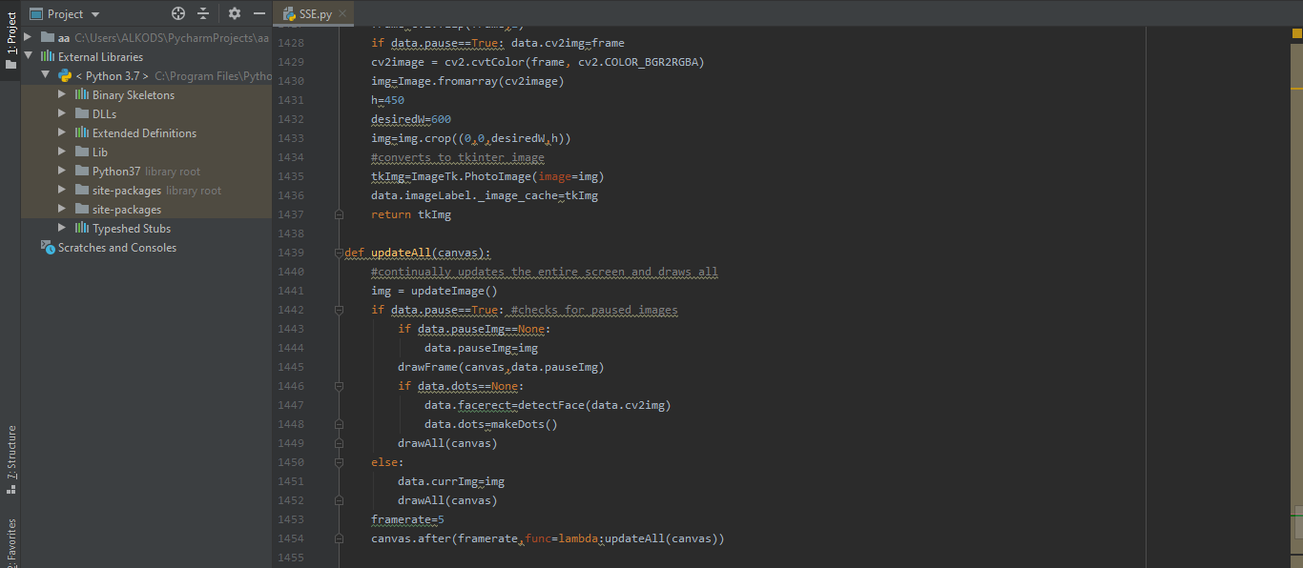

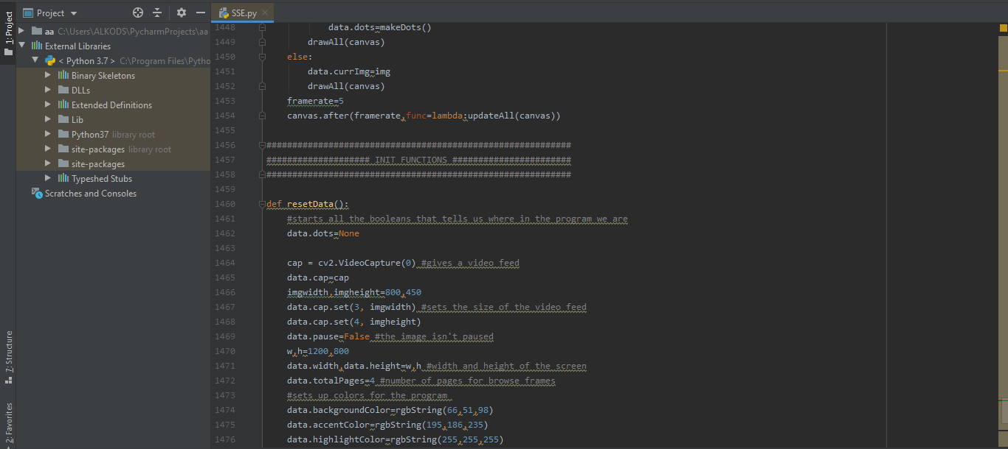

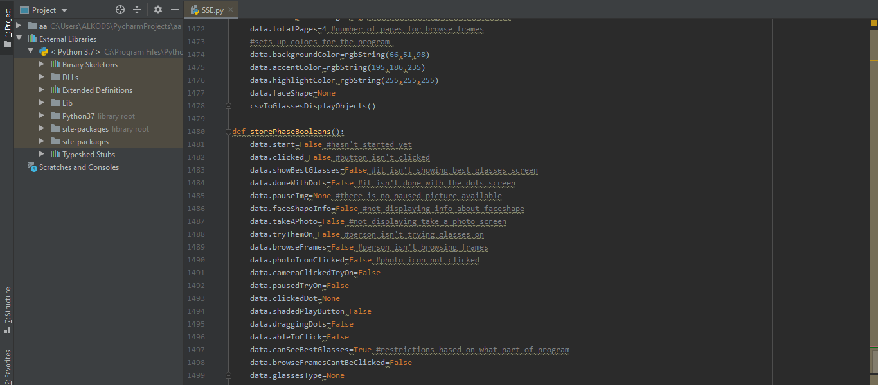

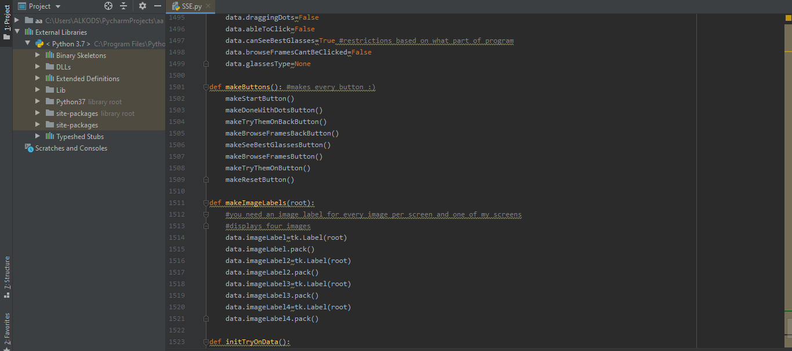

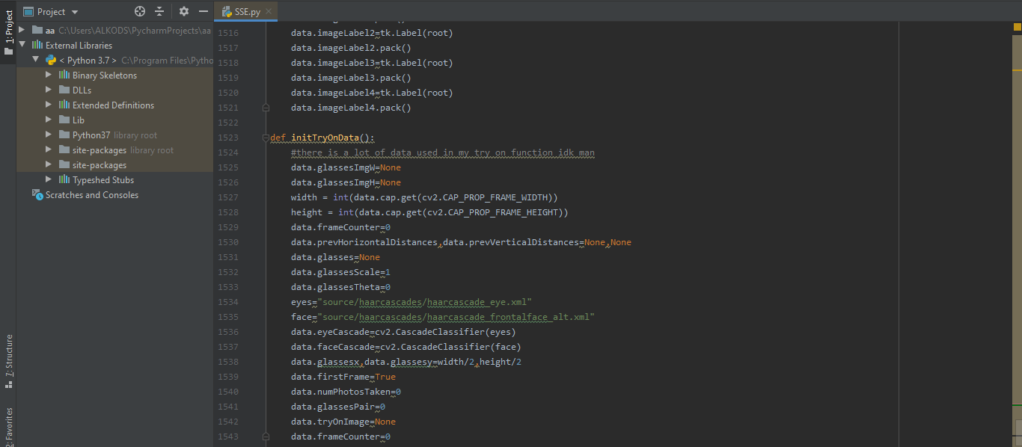

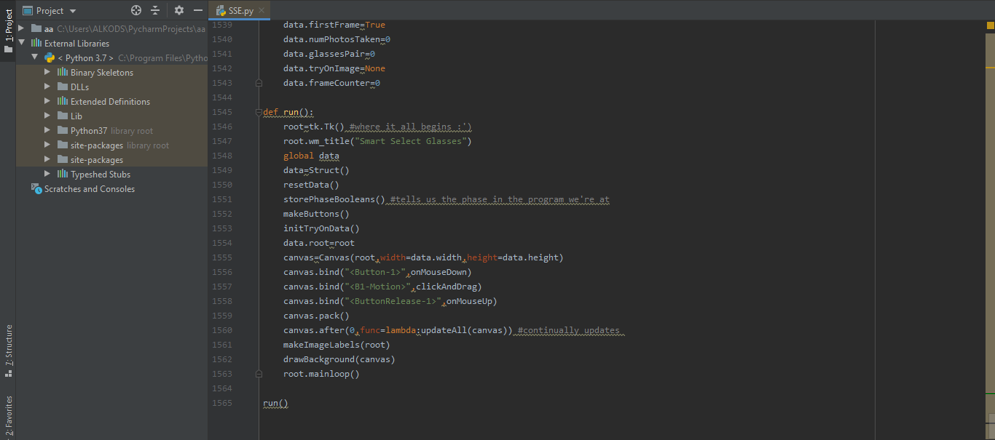

* **Chapter 5:**

5.1 How Does Application Work:

## **The application contains many wonderful functions that help some people who do not have time to go to the eyeglasses store and buy glasses; The application provides a feature to help them choose glasses that are compatible with the face in real dimensions and can be ordered online. It also helped people with vision impairments who find it difficult to choose suitable glasses for them.**

## **First, the user opens the application, then takes a picture of the face.**

## **Second, the "done" icon appears, and after that a number of options that fit the face appear.**

## **Third, he presses on the glasses, so they are attached to the face with real dimensions and he can order them.**

* **Chapter 6:**
* **Conclusion:**

**From the beginning, I have tried to keep focused to achieve the aims of the projects. To assemble a solid framework which I consider a smaller than normal creating stage that helps the engineers and encourage their works and not fail to remember the end-clients who are the main piece of the turn of events. What's more, to accomplish the best outcome I recollect myself consistently with the SSG**

* **Principles:**
* **Your greatest resource is your time.**
* **Simplicity is the secret to success.**
* **Track code errors, and overcome them!**

**Create project "Smart select Glasses (SSG)" was not easy, it required me to reviews many resources that I already finished at AOU for example in the requirements, analysis,**

**and testing chapters I return to the TM366, TM354 subject tutorials many times to read about the functional and non-functional requirements and to apply the unit and integration testing for my system.**

**In the design and implementation stages, I always respect (usability, flexibility, reliability, and usable) characteristics.**

**By focusing on the part of software engineering that maintains the final product to make the system survive for a long time and not to be an outdated system over time.**

**Finally, I am happy with the results and achieved goals after this long and arduous journey. I hope that I can continue on the principle of continuous development and work to integrate this concept into the world of software engineering in more broadly and comprehensively ways. I think the most important thing I've learned during my journey in AOU and especially in this project is to do your best at the beginning instead of starting weak and spending your time and efforts later.**

* References:

**Pasupa, K., Sunhem, W., & Loo, C. K. (2019). A hybrid approach to building face shape classifier for hairstyle recommender system. Expert Systems with Applications, 120, 14-32.**

[**https://www.sciencedirect.com/science/article/abs/pii/S0957417418307346?via%3Dihub**](https://www.sciencedirect.com/science/article/abs/pii/S0957417418307346?via%3Dihub)

**Mane, S., & Shah, G. (2019). Facial recognition, expression recognition, and gender identification. In Data Management, Analytics, and Innovation (pp. 275-290). Springer, Singapore.**

[**https://link.springer.com/chapter/10.1007/978-981-13-1402-5_21**](https://link.springer.com/chapter/10.1007/978-981-13-1402-5_21)

**Lanitis, A., Taylor, C. J., & Cootes, T. F. (1995). Automatic face identification system using flexible appearance models. Image and vision computing, 13(5), 393-401.**

[**https://www.sciencedirect.com/science/article/abs/pii/026288569599726H**](https://www.sciencedirect.com/science/article/abs/pii/026288569599726H)

**Wikihow.com. 2020. 3 Ways To Determine Your Face Shape - Wikihow. [online] Available at:**

**< https://www.wikihow.com/Determine-Your-Face-Shape > [Accessed 3 May 2020].**

**FramesDirect.com. 2020. Face Shape Guide: How To Choose The Best Glasses For Your Face. [online] Available at:**

**<** [**https://www.framesdirect.com/knowledge-center/face-shape-guide**](https://www.framesdirect.com/knowledge-center/face-shape-guide) **> [Accessed 3 May 2020].**

**Fetch Eyewear. 2020. The Best Glasses For Your Face Shape | Find Your Fit | Fetch Eyewear. [online] Available at**: **<** [**https://fetcheyewear.com/pages/find-your-fit-face-shape**](https://fetcheyewear.com/pages/find-your-fit-face-shape) > [Accessed 12 June 2020].

**Shape?, H., 2020. What Glasses Will Suit My Face? | Glasses Direct. [online] Glassesdirect.co.uk. Available at**: **<** [**https://www.glassesdirect.co.uk/face-shapes/**](https://www.glassesdirect.co.uk/face-shapes/) **> [Accessed 14 May 2020].**

**FramesDirect.com. 2020. Face Shape Guide: How To Choose The Best Glasses For Your Face. [online] Available at: <**[**https://www.framesdirect.com/knowledge-center/face-shape-guide**](https://www.framesdirect.com/knowledge-center/face-shape-guide) **> [Accessed 14 May 2020].**